PROCEDIMEINTOS NORTEL OPCION 11C
System software installation
Contents

This section contains information on the following topics:

Reference list . . . . . . . . . . . . . . . . . . . . . . . . . . . . . . . . . . . . . . . . . . . . . 233
General information . . . . . . . . . . . . . . . . . . . . . . . . . . . . . . . . . . . . . . . . 233
General information . . . . . . . . . . ... . . . . . . . . . . . . . . . . . . . . . . . . . . . . 243
Keycode Information . . . . . . . . . …... . . . . . . . . . . . . . . . . . . . . . . . . . . 233
How to install software in a new system . . . . …… . . . . . . .. . . . . . . . . 234
Software installation on the IP Expansion Cabinet using the
preprogrammed software daughterboard . . . . . . …... . . . . . . . . . . . . . . 244

Reference list
The following are the references in this section:
• Option 11C and 11C Mini Fault Clearing (553-3011-500)
• Maintenance (553-3001-511)

General information
This Chapter describes how to install software in a new Option 11C system.
Before continuing with the procedures outlined in this Chapter, verify that all
pertinent hardware is either connected to, or installed in the system.

Keycode Information
Data you need to enter during the software installation is provided on the
Keycode Datasheet.

If the keycodes are unsuccessful, check the following:

• software issue
• feature set name
• any additional packages
• TNs
• ISM parameters
• security ID
• auxiliary ID (the old site ID, if this is an upgrade)
• ensure the correct keycodes were entered. All items must match the

Keycode Datasheet exactly.
For an Option 11C Mini system, check that the number of TNs has been
entered correctly from the keycode sheet.

When performing a new system installation, please ensure that the default
AUX ID matches the AUX ID from the Keycode Datasheet.

If they still are not successful, then call your Service Representative.
How to install software in a new system
Summary of steps
The Software Installation steps are summarized in the following list:
• Get MAC address from IP daughterboard
• Power up/Install IP Expansion cabinet
• Power up Main cabinet. Ensure link led is green
• Perform software installation on the Main cabinet
• Select the New System Installation menu
• Select Feature Set and packages
• Select a database
• Select Incremental Software Management (ISM) parameters.
Ensure Survivability parameter is configured correctly
• Configure MAC addrress of the IP Expansion cabinet
Option 11C Planning and Installation Guide
• Validate keycodes
• Set the system time and date
• Reboot the Main cabinet
• Wait for link to come up.

Note: IP expansion cabinet software must be the same software
version as the main Option 11C cabinet.

Procedure 38
Installing the software

Note: This procedure assumes that the system installation
procedures in Chapter 8 have been performed and that the system is
up and running. The Link LED on the software daughterboards should
be lit and green.

1.- Observe the terminal screen.
If the following is displayed:

SOFTWARE INSTALLATION PROGRAM

proceed to Step 3.
If the following is displayed:
Current system time and date: 00:00:00 -- 00/00/00

proceed to Step 2.
If neither message appears, refer to the Option 11C and 11C Mini Fault
Clearing (553-3011-500).

2 .-Set the system time and date.

CAUTION
Wear the antistatic wrist strap provided in the bottom of the
cabinet before handling circuit cards. Static electricity can
damage the components of power supplies and circuit cards.
553-3021-210 Standard 7.00 January 2002

Note: The Time and Date prompt appears only when the Install Setup
Program detects a system Year Date that is not in the range of
1995-2095. The responses shown below are examples of how to enter
the system Time and Date:

Enter new time (hh/mm/ss)
08:00:00 <cr>

Enter new date (yy/mm/dd)
95/05/01 <cr>

08:00:00 -- 95/05/01 is the new system time and date

y <cr>

3.- Select Menu option 1 for a new installation.

Main Cabinet Software Installation Main Menu:
1. New Install or Option 11/11E Upgrade - From Software Daughterboard
2. System Upgrade
3. Utilities
4. New System Installation - From Software Delivery Card
[q]uit, [p]revious, [m]ain menu, [h]elp or [?], <cr> - redisplay
Enter selection: 1<cr>

Meridian 1 Software Rls (25.40) will be installed.

Note: The following prompts require information from the Keycode
data sheet. Please have it available.

4.- Select the Feature Set to be enabled.

Note: The Feature Set selected must match the ones provided with
key codes on the keycode data sheet. The Feature Set names shown
below are examples only.

Select Feature Set You Wish to Enable:

1. General Business (NTSKxxxx)
2. Enhanced Business (NTSKxxxx)
3. Enterprise (NTSKxxxx)
4. NAS/VNS (NTSKxxxx)
[q]uit, [p]revious, [m]ain menu, [h]elp or [?], <cr> redisplay

(example only:)

Enter Selection: 2 <cr> (Enhanced Business)

5.- Indicate whether or not packages are to be added.

Feature Set Selection: Enhanced Business

Do you wish to add packages?
Select no, yes or abort:

n <cr> (no)
y <cr> (yes)
a <cr> (abort)

Note: Abort returns you to the main menu.

If the response was NO go to Step 8 on page 238.
If the response was YES go to Step 6 on page 237.

6.- Select the Feature packages to be added.

Summary of Packages selected is:
0-2 4-5 7-14 16-25 28-29 32-64 67 70-77 79-83 86-93 95 98-104
107-111 113-116 118-120 122-125 127-129 131-133 135 137-141 167

Enter packages (s) to be added, blank line to end:
215-235 <cr>

Note: (<cr> ends selection entry or if no packages are to be added).

7.- Confirm Feature Set and packages.

Your Feature Set Selection is “Enhanced Business”:
Additional Packages selected: 215-235
Summary of Packages selected is:
0-2 4-5 7-14 16-25 28-29 32-64 67 70-77 79-83 86-93 95 100-104 107-111
113-116 118-120 122-125 127-129 131-133 135 137-141 167
...
...
215-235

Is this selection correct?
n <cr> (no)
y <cr> (yes)
a <cr> (abort, return to main menu)

If the response was NO go to Step 4 on page 236.
If the response was YES go to Step 8 on page 238.

8 Select a Database.

Select menu option 1 or 2 for a new system installation:
1. Pre-Configured database - Enhanced Business
2. Basic Configuration (Release 22)
3. CCBR Restore File
4. Option 11/11E Software Cartridge
[q]uit, [p]revious, [m]ain menu, [h]elp or [?], <cr> redisplay

Enter Selection: 1 <cr>.

9.- Confirm database selection.

Do you wish to continue?
n <cr> (no)
y <cr> (yes)
a <cr> (abort, return to main menu)

If the response was No, go to Step 8 on page 238.
If the response was YES, go to Step 10 on page 238.

10.- Review ISM parameters.

Note: On a new installation, the ISM parameters displayed on the
terminal screen will be the default settings associated with the Feature
Set selection. These settings can be accepted without changes or
changed to suit the requirements of the new system.
Example: Current ISM Parameters: Parameter Description

TNS (100) maximum number of terminal numbers
ACDN (300) maximum number of ACD DNs
AST (100) (maximum number of associate Sets
LTID (100) maximum number of Logical Terminal IDs
RAN CON (12) default RAN connection
RAN RTE (2500) default RAN routes
MUS CON (100) default MUS connection)
BRAND (0) brandline
ACD AGENTS (300) maximum number of ACD agents
ANALOGUE TELEPHONES (2500) maximum number of analogue sets
ATTENDANT CONSOLES (2500) maximum number of attendant sets
BRI DSL (100) maximum number of Digital Subscriber loops
CLASS TELEPHONES (2500) maximum number of class sets
DATA PORTS (2500) maximum number of data ports
DIGITAL TELEPHONES (2500) maximum number Digital sets
INTERNET TELEPHONES (0) maximum number of Internet sets
PHANTOM PORTS (2500) maximum number of phantom ports
WIRELESS TELEPHONES (2500) maximum number Wireless sets
WIRELESS VISITORS (0) maximum number Wireless Visitors
ITG ISDN TRUNKS (2500) maximum number ISDN trunks
TRADITIONAL TRUNKS (2500) maximum number of traditional trunks
TMDI D-CHANNELS (100) maximum number of channels
SURVIVABILITY (0) Number of Survivable IP expansion cabinets

Do you wish to change ISM parameters?
n <cr> (no change)
y <cr> (change)
a <cr> (abort, return to main menu)

If the response was YES go to Step 11 on page 239.
If the response was NO go to Step 12 on page 241.
11.- Select ISM parameters.

Do you wish to change any ISM parameters? (y/n/[a]bort): y

Enter new ISM parameters, <cr> to leave unchanged:
TNS (100) 200
ACDN (300)
AST (100)
LTID (100)
RAN CON (12)
RAN RTE (2500)
MUS CON (100)
BRAND (0)
ACD AGENTS (300)
ANALOGUE TELEPHONES (2500)
ATTENDANT CONSOLES (2500)
BRI DSL (100)
CLASS TELEPHONES (2500)
DATA PORTS (2500)
DIGITAL TELEPHONES (2500)
INTERNET TELEPHONES (0)
PHANTOM PORTS (2500)
WIRELESS TELEPHONES (2500)
WIRELESS VISITORS (0)
ITG ISDN TRUNKS (2500)
TRADITIONAL TRUNKS (2500)
TMDI D-CHANNELS (100)
SURVIVABILITY (0) 4
Confirm ISM parameters.

New ISM parameters are:

TNS (200)
ACDN (300)
AST (100)
LTID (100)
RAN CON (12)
RAN RTE (2500)
MUS CON (100)
BRAND (0)
ACD AGENTS (300)
ANALOGUE TELEPHONES (2500)
ATTENDANT CONSOLES (2500)
BRI DSL (100)
CLASS TELEPHONES (2500)
DATA PORTS (2500)
DIGITAL TELEPHONES (2500)
INTERNET TELEPHONES (0)
PHANTOM PORTS (2500)
WIRELESS TELEPHONES (2500)
WIRELESS VISITORS (0)
ITG ISDN TRUNKS (2500)
TRADITIONAL TRUNKS (2500)
TMDI D-CHANNELS (100)
SURVIVABILITY (4)
Is this correct?

n <cr> (no)
y <cr> (yes)
a <cr> (abort, return to main menu)

If the response was NO go to Step 10 on page 238.
If the response was YES go to Step 12 on page 241.
12.- Define the AUX ID.

Note: The default AUX ID is the security ID provided with the Option
11C. It should be replaced with the previous Option 11 or Option 11E

site ID.
Example:
Security ID: 10000326
Current AUX ID: 10000326
Do you wish to change the AUX ID?
y <cr> (yes)
n <cr> (no)
a <cr> (abort, return to main menu)

If the response was NO go to Step 14 on page 242.
If the response was YES go to Step 13 on page 241.

13.- Enter the AUX ID.

Enter the Option 11/11E Security ID for the new AUX ID,
<cr> to maintain
12121212 <cr>
New AUX ID: 12121212
Is this correct?
y <cr> (yes)
n <cr> (no)
a <cr> (abort, return to main menu)

If the response was NO go to Step 12 on page 241.
If the response was YES go to Step 14 on page 242.
14 .-Review and confirm information entered.

New Installation Information Summary:
Security ID : xxxxxxxx
Aux ID : xxxxxxxx
Cabinet Type : MAIN
Feature Set : Enhanced Business
Additional Pkgs : 215-235
Database : Company ABC
OLD NEW
S/W Release : 2520F 2520X
ISM Parameters

TNS 200 200
ACDN 300 300
AST 100 300
LTID 100 100
RAN CON 12 12
RAN RTE 2500 2500
MUS CON 100 100
BRAND 0 0
ACD AGENTS 300 300
ANALOGUE TELEPHONES 2500 2500
ATTENDANT CONSOLES 2500 2500
BRI DSL 100 100
CLASS TELEPHONES 2500 2500
DATA PORTS 2500 2500
DIGITAL TELEPHONES 2500 2500
INTERNET TELEPHONES 0 0
PHANTOM PORTS 2500 2500
WIRELESS TELEPHONES 2500 2500
WIRELESS VISITORS 0 0
ITG ISDN TRUNKS 2500 2500
TRADITIONAL TRUNKS 2500 2500
TMDI D-CHANNELS 100 100
SURVIVABILITY 4 4
Is this correct?

y <cr> (yes)
n <cr> (no)
a <cr> (abort, return to main menu)

If the response was NO go to Step 4 on page 236.
If the response was YES go to Step 15 on page 243.
15.- Enter the keycodes

Note: See Keycode Information on page 233 for important
information on Keycodes.

Enter new Keycodes:

Example:
Key 1:
Key 2:
Key 3:
xxxxxxxx <cr>
yyyyyyyy <cr>
zzzzzzzz <cr>

Keycode validation successful.

***WARNING*** A system restart will be invoked as part of the
software installation process.

If the successful message appears go to Step 16 on page 243.
If the unsuccessful message appears, repeat this step, Step 15 on page 243.

After three unsuccessful keycode validation attempts, the following
message appears:

Keycode validation unsuccessful.

Installation aborted….returning to main menu.

16 .-Complete the software installation.

Are you sure you wish to perform the installation?
y <cr> (yes)
n <cr> (no)
a <cr> (abort, return to main menu)

If the response was No go to Step 3 on page 236.
If the response was YES this is the end of the software installation
program. Continue with the next step, Step 17 on page 243.

17.- Observe the screen a second time once the installation program has
been completed.

Messages will appear on the TTY or terminal screen. When the
message “INIXXX” appears, the system is operational.

18.- Perform an EDD using LD 43. Refer to Maintenance (553-3001-511)
for further information on LD 43.

19.- Configure the IP Daughterboards’ MAC and IP addresses. Refer to
LD 117 in Maintenance (553-3001-511).

—————————— End of Procedure ——————————

Software installation on the IP Expansion Cabinet using the
preprogrammed software daughterboard

Point-to-Point or Layer 2 with bootp configuration

For Point-to-Point or Layer 2 with bootp configuration, you do not need a
TTY connected to the IP Expansion Cabinet. Power up the system, and the
software installs automatically.
Layer 2 or Layer 3 with manual configuration
IMPORTANT
BootP is a broadcast message used for IP Address discovery.
• For Point-to-Point installation, you must select Option 1.
• For Layer 2 LAN installation, the recommended selection is
Option 1.
• For Layer 3 LAN installation, you must select Option 2.

Procedure 39
Software installation for IP expansion, using the preprogrammed
software daughterboard
Note: This procedure is performed from a TTY connected to the IP
Expansion Cabinet

1 Power up the system, and the menu in Step 2 appears.

2 Select Manual Configuration (item 2) from the IP Expansion Cabinet
Configuration Menu.

The IP Configuration Menu is displayed:
IP Configuration Menu:
1. Automatically Using BootP
2. Using Manual Configuration
3. Keep Existing Configuration
[q]uit, [p]revious, [m]ain menu, [h]elp or [?], <cr>
- redisplay

Enter Selection: 2
3.-Configure IP Expansion Parameters.

For the following menu, the sample IP parameters will be used:

IP address of the expansion cabinet 100BaseT(F): 47.147.20.101;
Subnet Mask of the expansion cabinet 100BaseT(F): 255.255.255.0;
Gateway address: 47.147.20.1;
IP address of the main cabinet 100BaseT(F): 47.147.10.100.

The IP Parameters menu is displayed:

Enter Expansion New IP Parameters:
Expansion IP: 47.147.20.101
Expansion NetMask: 255.255.255.0
Main IP: 47.147.10.100

Expansion Router/Gateway: 47.147.20.1

Is this correct? (t/n/[a]bort): Y

Note: ‘Expansion Router/Gateway’ appears only in a Layer 3
configuration.

4.- The software installation is completed automatically without user
intervention.

5 Refer to Software Input/Output Guide Maintenance (553-3001-511)
LD 117 to configure the IP Expansion cabinets IP Address.

—————————— End of Procedure ——————————

Connecting the telephones
Contents

This section contains information on the following topics:

Reference list . . . . . . . . . . . . . . . . . . . . . . . . . . . . . . . . . . . . . . . . . . . . . 247
General information . . . . . . . . . . . . . . . . . . . . . . . . . . . . . . . . . . . . . . . . 248
Cross-connecting telephones . . . . . . . . . . . . . . . . . . . . . . . . . . . . . . . . . 249
Connecting telephones without a PFTU . .. . . . . . . . . . . . . . . . . . . . . . . 251
Connecting 500/2500-type telephones with a PFTU . . . . . . . . . . . . . . . 252
Connecting off-premise telephones . . . . . . . . . . . . . . . . . . . . . . . . . . . . 253
Connecting an attendant console . . . . . . . . . . . . . . . . . . . . . . . . . . . . . . 255
Cross-connecting terminal Digital Subscriber Loops . . . . . . . . . . . . . . 269
Activating telephones . .. . . . . . . . . . . . . . . . . . . . . . . . . . . . . . . . . . . . . 269
Activating a default model with a character display . . . . . . . . . . . . . . . 270
Activating a default model without a character display . .. . . . . . . . . . . 272
Activating a customized model with a character display . .. . . . . . . . . . 273
Activating a customized model without a character display . . . . . . . . . 275
Activating terminals on a DSL . .. . . . . . . . . . . . . . . . . . . . . . . . . . . . . . 276

General information
This chapter contains instructions for connecting telephones to the
cross-connect terminal. It also contains the location of the individual
extension numbers (DNs) when you are implementing one of the default
numbering plans and how to activate each telephone.

Refer to the instructions provided with the telephone or console and to
Telephone and Attendant Console: Installation (553-3001-215) for detailed
information about installing telephones and consoles.

The cable from the cabinet card slot containing the line card associated with
the telephone being connected, must be installed before you continue. Refer
to “Installing and connecting cross-connect terminals to cabinets” on
page 169, if additional cabling is required.

Cable assignments
The cables from each cabinet are labeled J1 through J10 at the cross-connect
terminal. Each cable represents a specific set of Terminal Numbers (TNs) as
shown in Table 37 on page 258.

WARNING
Always use caution when installing or modifying telephone lines.
Avoid installing telephone wiring during a lightning storm. Do not
install telephone jacks in wet locations unless the jack is specifically
designed for wet locations. Never touch uninsulated telephone wiring
unless the line has been disconnected at the network interface.

Cross-connecting telephones

Connect the telephones according to the following figures. Cross-connections
for Analog (500/2500 type) telephones are shown in Figure 94 on page 250,
and for Meridian Digital Telephones in Figure 95 on page 251.

Procedure 40
Cross-connecting telephones

1.- Locate telephone terminations at the cross-connect terminal.

2.- Connect Z-type cross-connecting wire to the leads of the
telephone.

3.- Locate line circuit card (TN) terminations at the cross-connect
terminal.

4.- Connect the other end of the cross-connecting wire to the
assigned TN terminal block.

Figure 94
NE-500/2500-type telephone cross-connections

Figure 95
Meridian Digital Telephone cross-connections
Connecting telephones without a PFTU

Procedure 41
Connecting telephones without a PFTU

1.- Locate the telephone terminations on the cross-connect terminal.

2.- Connect one end of the cross-connect wire to the leads of the
Telephone

3.- Locate the line card terminations on the cross-connect terminal.

Refer to Table 37 on page 258 and Table 38 on page 259.

4.- Connect the other end of the cross-connect wire to the assigned
TN terminal block.
Default DN assignments are given in the following Tables:

• Table 42, “Main Cabinet Default DN assignments,” on
page 263

• Table 43, “Expansion Cabinet 1 Default DN assignments,” on
page 264
• Table 44, “Expansion Cabinet 2 Default DN assignments,” on
page 265

• Table 45, “Expansion Cabinet 3 Default DN assignments,” on
page 267

• Table 46, “Expansion Cabinet 4 Default DN assignments,” on
page 268

The telephone can now be activated as described in “Activating
telephones” on page 269.

Note: All the following tables show the default DNs.

Connecting 500/2500-type telephones with a PFTU

Procedure 42
Connecting 500/2500-type telephones with a PFTU

1 .- Locate the telephone terminations on the cross-connect terminal.

2.- Connect one end of the cross-connect wire to the leads of the
telephone.

3 .- Locate the PFTU connections (unit PFT 1 through PFT 5)
assigned to this telephone at the cross-connect terminal.

Refer to Table 39 on page 261 and Table 40 on page 262.

4.- Connect the other end of the cross-connect wire to the pair
assigned to the telephone on the PFTU.

5 .- Connect a second cross-connect wire to the pair assigned to the
line card on the PFTU.

6.- Locate the line card terminations on the cross-connect terminal.

Refer to Table 37 on page 258 for the Main cabinet and Expansion
cabinets 1 and 2.

Refer to Table 38 on page 259 for Expansion cabinets 3 and 4.

7.- Connect the other end of the cross-connect wire to the assigned
TN terminal block
Default DN assignments are given in the following Tables:

• Table 42, “Main Cabinet Default DN assignments,” on
page 263
• Table 43, “Expansion Cabinet 1 Default DN assignments,” on
page 264

• Table 44, “Expansion Cabinet 2 Default DN assignments,” on
page 265

• Table 45, “Expansion Cabinet 3 Default DN assignments,” on
page 267

• Table 46, “Expansion Cabinet 4 Default DN assignments,” on
page 268
The telephone can now be activated as described in “Activating
telephones” on page 269.

Connecting off-premise telephones

Off-premise 500/2500-type telephones must be connected through an
NTAK92AA Off-Premise Protection module. Each module can connect up to
four analog telephones and can interface with an NT1R20 Off-Premise
Station analog Line Card, an NT8D03 Analog Line Card or with an NT8D09
Message Waiting Line Card.

WARNING
The message waiting line card produces -150 volts which is considered
hazardous on off-premise telephones. Make sure that the -150 V is
disabled on off-premise telephones.

The voltage is disabled when the Class Of Service (CLS) assigned to
the telephone is LPD (message waiting lamp denied) and MWD
(Message Waiting Denied) in LD 10.

Refer to Software Input/Output Guide Maintenance (553-3001-511)
for information about LD 10.

Under no circumstances shall LPA or MWA be assigned in the Class of
Service on off-premise telephones

Procedure 43
Connecting an off-premise telephone

1 Mount the NTAK92AA Off-Premise protection module on the wall
using four #10 1/2 in (minimum) screws.

2 Connect a #6 AWG (#40 Metric Wire Gauge) from the ground lug
at the bottom of the NTAK92AA Off-Premise protection module to
an earth ground. Refer to Figure 96 on page 256.

WARNING
If connecting to a message waiting line card, unseat the card from its
assigned slot before proceeding with the next step
3 Connect two NTAK9204 cables (one from connector J1 and one
from connector J2) from the protection module to the
cross-connect terminal.

Terminate the cables as shown in Figure 94 on page 250.

4 Cross-connect the J1 cable to the Tip and Ring connections
coming from the line card.
Default DN assignments are given in the following Tables:

• Table 42, “Main Cabinet Default DN assignments,” on
page 263

• Table 43, “Expansion Cabinet 1 Default DN assignments,” on
page 264

• Table 44, “Expansion Cabinet 2 Default DN assignments,” on
page 265

• Table 45, “Expansion Cabinet 3 Default DN assignments,” on
page 267

• Table 46, “Expansion Cabinet 4 Default DN assignments,” on
page 268
5 Cross-connect the J2 cable to the off-premise telephone.

6 Install the regulatory label provided with the Off-Premise
protection module on the inside right-hand wall of the cabinet
near the velcro wriststrap fastener.
7 Install the line card in its assigned position.
The telephone can now be activated as described in “Activating
telephones” on page 269

Connecting an attendant console

Procedure 44
Connecting attendant console
1 Locate the attendant console terminations at the cross-connect
terminal.

2 Locate the line card terminations at the cross-connect terminal.

3 With cross-connect wire, connect the line card and other
connections to the console as shown in Figure 97 on page 257.

Figure 96
NTAK92AA Off-Premise Protection Module connections

Figure 97
Attendant console connections

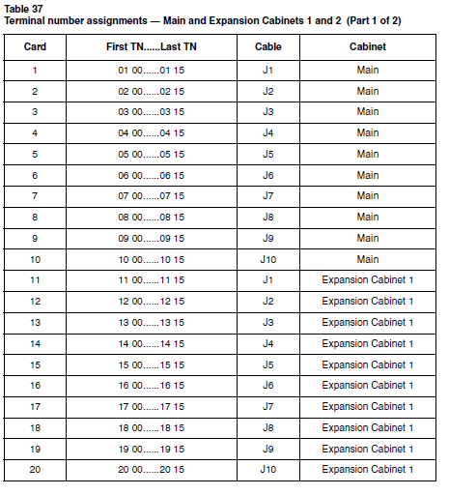
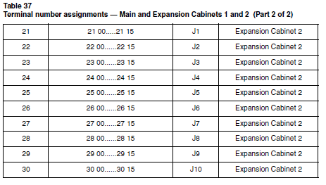

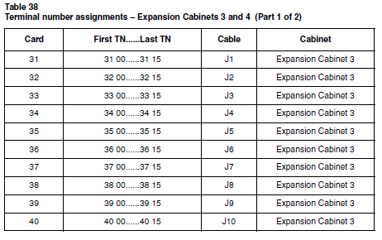

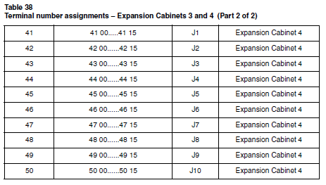

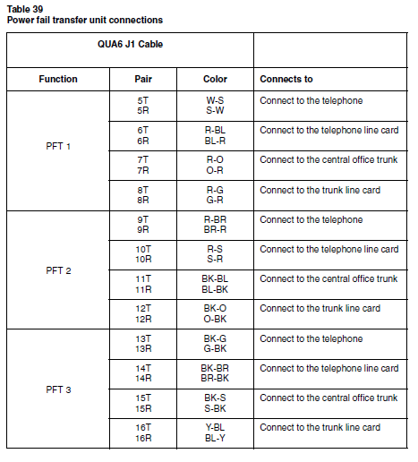
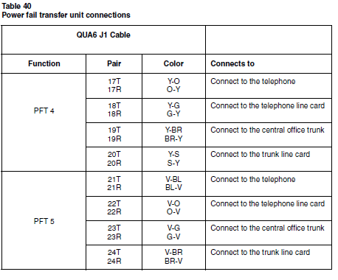
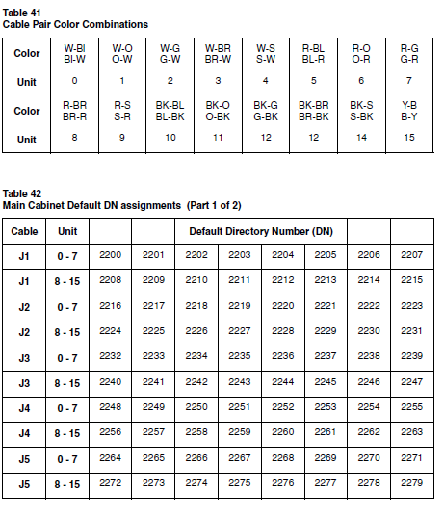

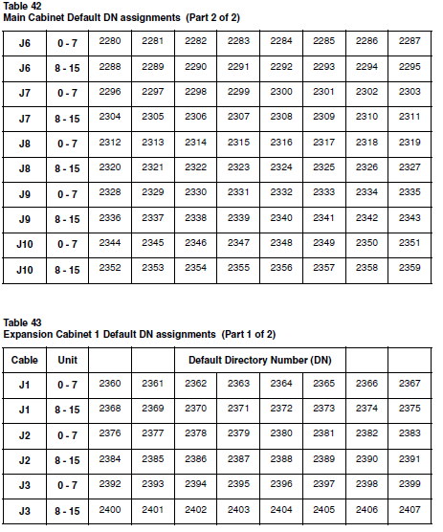

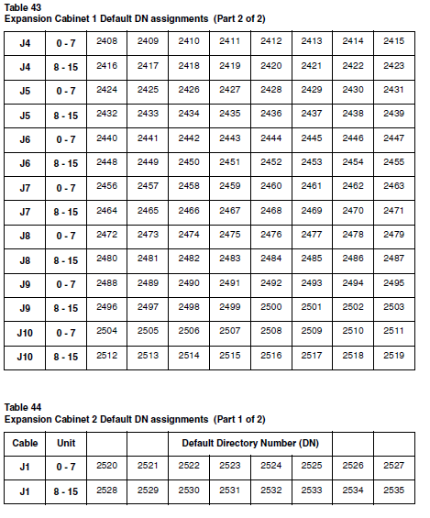
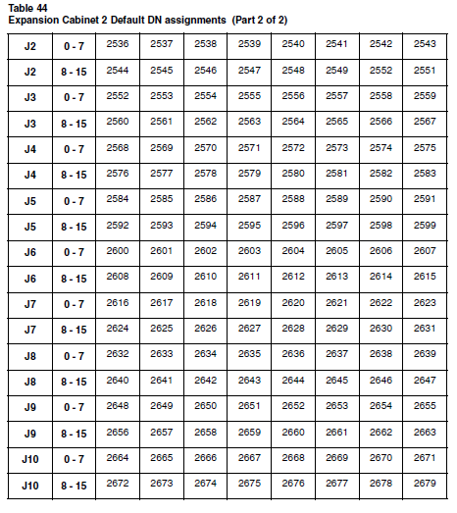
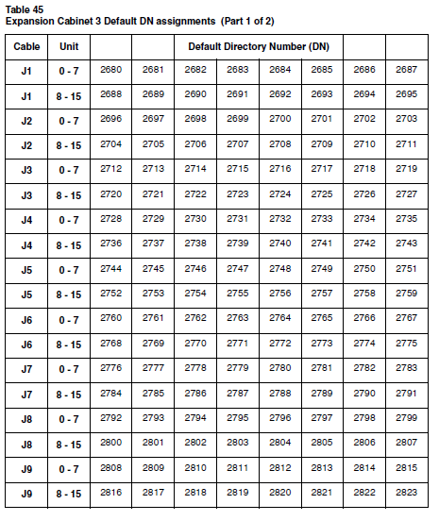
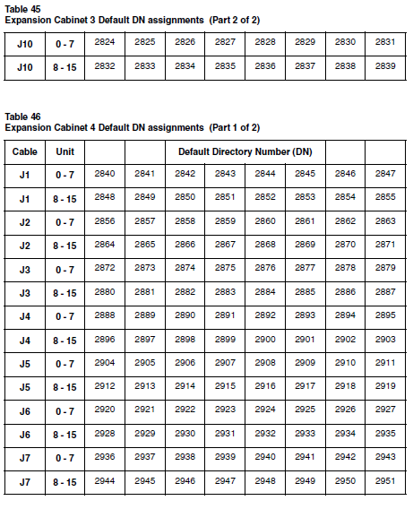
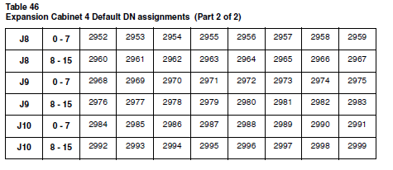
Cross-connecting terminal Digital Subscriber Loops

Refer to Option 11C ISDN BRI Hardware Installation and Maintenance
(553-3011-311), for a complete description of terminal Digital Subscriber
Loops (DSL) cross-connecting and installation.

Activating telephones
Activating telephones is straightforward. You activate each telephone by
carrying out a procedure on the telephone itself. The software feature used to
activate telephone sets is called “Automatic Set Configuration.”

Note: The data feature cannot be activated using the procedures in this
chapter. If you want to program a telephone with the data feature, you
must manually program it in LD 11 with Data class of service as
described in Software Input/Output Guide Maintenance
(553-3001-511).

Procedures for activating the following models of telephones are outlined:

• a default model with default extension number

• a customized model with a customized extension number.

These procedures are presented for telephones with and without character
displays.
Telephone tones

There are a number of different telephone tones. The following table includes
tones that you will hear during telephone activation:
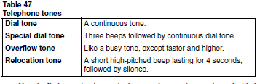
Note 1: Before activating a telephone, make sure that you have decided
on its final location and are aware of the model number assigned to it and
if it is to be customized.
Note 2: When activating Meridian Digital telephones, remember that
they differ from the older Meridian Modular telephones. Meridian
Modular telephones are allowed a combined total of 128 model
telephones, whereas Meridian Digital telephones are allowed 128 models
for each type of telephone. When you activate a Meridian Digital
telephone, you must select the model associated with that telephone type
or the telephone will not work.

Activating a default model with a character display

Procedure 45
Activating the telephone

1 Plug the telephone set into the jack and wait 20 seconds before
picking up the handset. If you do not receive a dial tone, replace
the handset and wait another 10 seconds before going off-hook
again. Repeat this procedure until dial tone is received.

If successful, the character display shows either “MODEL? X” (if the
telephone relocation feature is not in use) or “RELOC OR MODEL? X”
(if the telephone relocation feature is in use). “X” represents the default
model for the telephone that you are activating.
Note 1: If you do not see the prompt “MODEL X” after lifting the
handset, disconnect the telephone from the wall jack, wait five
seconds, and re-insert the telephone into the jack. The telephone now
shows “MODEL X” when you lift the handset.

Note 2: The 20 second time interval is required for the system to
determine whether the set is new or if it is being relocated using the
Modular Telephone Relocation feature.
2 Press the pound key (#) to select the default model.

The character display shows “OK, EXTENSION? XXXX”. “XXXX”
represents the default extension number for this telephone type.
3 Press the pound key again to select the default extension
number.

You hear the relocation tone. The character display, shows “OK”.

OR

If the extension number is already in use by another telephone, you
hear the special dial tone. If the telephone has a display it shows
“MULTI-LINE, EXTENSION?”.

To accept the default extension number press the pound key.

To select a new extension number, manually enter an extension
number and press the pound key.

OR

If the extension number is not available for use, the character display
shows “ERROR, EXTENSION?“ and you hear overflow tone.
This happens when you choose an extension number manually or
when extension numbers are entered for additional keys. A default
extension number will not be offered if it is not available.
Step 3 must be repeated and you must manually enter a new
extension number.

Note 1: If other keys require secondary extension numbers, you are
prompted until you enter all of the required extension numbers for the
model.

Note 2: These extension numbers cannot be defaulted. The text
display prompting for further extension numbers is “KEY kk EXT?”
where “kk” represents the key number requiring the extension number.
Page 272 of 408 Connecting the telephones

Note 3: Each prompt for another extension number is accompanied
by special dial tone. When you are programming an extension number,
the lamp associated with that number on the telephone is lit.
4 Hang up the telephone receiver.

After approximately 10 seconds, the telephone is configured.

Note: If you replace the handset before completing the prompt
sequence, the installation will automatically fail. This can be useful if
you make an error and want to restart the procedure.

Activating a default model without a character display

Procedure 46
Activating the telephone

1 Plug the telephone set into the jack and wait 20 seconds before
picking up the handset. If you do not receive dial tone, replace the
handset and wait another 10 seconds before going off-hook
again. Repeat this procedure until dial tone is received.

Note: The 20 second time interval is required for the system to
determine whether the set is new or if it is being relocated using the
Modular Telephone Relocation feature.

2 Press the pound key (#) to select the default model.

3 Press the pound key again to select the default extension
number.

You hear a short, high-pitched beep lasting four seconds followed by
silence (relocation tone).

Note: If the extension number is already in use by another telephone,
you hear three beeps followed by continuous dial tone (special dial
tone).

To accept the default extension number press the pound key.

To select a new extension number, manually enter an extension
number and press the pound key.

If the extension number is not available for use, you hear a fast,
high-pitched broken tone (overflow tone). (This happens when you
choose an extension number manually or when extension numbers
are entered for additional keys. A default extension number will not be
offered if it is not available). Step 3 must be repeated and you must
manually enter a new extension number.

Note: If other keys require secondary extension numbers, you are
prompted until you enter all of the required extension numbers for the
model. These extension numbers cannot be defaulted. You are
prompted for each additional extension number with three beeps
followed by continuous dial tone (special dial tone). When you are
programming an extension number, the lamp associated with that
number on the telephone is lit.

Activating a customized model with a character display

Procedure 47
Activating a customized telephone

1 Plug the telephone set into the jack and wait 20 seconds before
picking up the handset. If you do not receive dial tone, replace the
handset and wait another 10 seconds before going off-hook
again. Repeat this procedure until dial tone is received.

If successful, the character display shows either “MODEL? X” (if the
telephone relocation feature is not in use) or “RELOC OR MODEL? X”
(if the telephone relocation feature is in use). “X” represents the default
model for the telephone that you are activating.

Note 1: If you do not see the prompt “MODEL X” after lifting the
handset, disconnect the telephone from the wall jack, wait five
seconds, and re-insert the telephone into the jack. The telephone now
shows “MODEL X” when you lift the handset.

Note 2: The 20 second time interval is required for the system to
determine whether the set is new or if it is being relocated using the
Modular Telephone Relocation feature.

2 Press the digits associated with the customized model and press
the pound key (#).

Dial tone disappears after the first digit is pressed and you hear special
dial tone after you press the pound key. If you enter a valid model
number the character display reads “OK, EXTENSION?”. If you enter
an invalid model, the previous prompt is reissued and you hear
overflow tone.

3 Enter the customized extension number and press the pound
key.

You hear relocation tone. The character display shows “OK”.

OR

If the extension number is already in use by another telephone, you
hear special dial tone again. The character display shows
“MULTI-LINE, EXTENSION?”.

OR

If the extension number is not available for use, you hear overflow
tone. The character display shows “ERROR, EXTENSION?” and you
must repeat this step.

Note: If other keys require secondary extension numbers, you are
prompted until you enter all of the required extension numbers for the
model. These extension numbers cannot be defaulted. The text
display prompting for further extension numbers is “KEY kk EXT?”
where “kk” represents the key number requiring the extension number.
Each prompt for another extension number is accompanied by special
dial tone. When you are programming an extension number, the lamp
associated with that number on the telephone is lit.

4 Hang up the telephone handset.
After approximately 10 seconds, the telephone is configured.

Note: If you replace the handset before you complete the prompt
sequence, the installation will automatically fail. This can be useful if
you make an error and want to restart the procedure.
Connecting the

Activating a customized model without a character display

Procedure 48
Activating a customized telephone

1 Plug the telephone set into the jack and wait 20 seconds before
picking up the handset. If you do not receive dial tone, replace the
handset and wait another 10 seconds before going off-hook
again. Repeat this procedure until dial tone is received.

Note: The 20 second time interval is required for the system to
determine whether the set is new or if it is being relocated using the
Modular Telephone Relocation feature.

2 Press the digits associated with the customized model and press
the pound key (#).

Dial tone disappears after the first digit is pressed, and you hear three
beeps followed by continuous dial tone (special dial tone) after you
press the pound key.

3 Enter the customized extension number and press the pound
key.

You hear a short high-pitched beep lasting four seconds, followed by
silence (relocation tone).
If the extension number is already in use by another telephone, you
hear special dial tone again.
If the extension number is not available for use, you hear a fast,
high-pitched broken tone (overflow tone), and you must repeat this
step.

4 Hang up the telephone handset.

After approximately 10 seconds, the telephone is configured.

Note: If other keys require secondary extension numbers, you are
prompted until you enter all of the required extension numbers for the
model. These extension numbers cannot be defaulted. You are
prompted for each additional extension number with three beeps
followed by continuous dial tone (special dial tone). When you are
programming an extension number, the lamp associated with that
number on the telephone is lit.

Activating terminals on a DSL

Refer to Option 11C ISDN BRI Hardware Installation and Maintenance
(553-3011-311), for information about activating and initializing the various
terminals that can be connected to a terminal DSL.

Connecting the trunks
Contents

This section contains information on the following topics:

Reference list . . . . . . . . . . . . . . . . . . . . . . . . . . . . . . . . . . . . . . . . . . . . . 278
General information . . . . . . . . . . . . . . . . . . . . . . . . . . . . . . . . . . . . . . . . 278
Connecting trunks without PFTU . . . . . . . . . . . . . . . . . . . . . . . . . . . . . 279
Connecting trunks with PFTU . . . . . . . . . . . . . . . . . . . . . . . . . . . . . . . . 279
Trunk Connections . . . . . . . . . . . . . . . . . . . . . . . . . . . . . . . . . . . . . . . . . 282
NT8D14 Universal trunk card . . . . . . . . . . . . . . . . . . . . . . . . . . . . . . . . 282
NT8D15 E&M Trunk card . .. . . . . . . . . . . . . . . . . . . . . . . . . . . . . . . . . 284
NT6D70 SILC and NT6D71 UILC cards . . . . . . . . . . . . . . . . . . . . . . . 286
Trunk connections (Europe) . .. . . . . . . . . . . . . . . . . . . . . . . . . . . . . . . . 286
E&M TIE trunk card (2-Wire) . . . . . . . . . . . . . . . . . . . . . . . . . . . . . . . . 286
E&M TIE trunk card (4-Wire) . . . . . . . . . . . . . . . . . . . . . . . . . . . . . . . . 288
E&M TIE trunk card (2280Hz) . . . . . . . . . . . . . . . . . . . . . . . . . . . . . . . 291
E&M TIE trunk card (RAN) . . . . . . . . . . . . . . . . . . . . . . . . . . . . . . . . . 292
E&M TIE trunk card (MUS) . . . . . . . . . . . . . . . . . . . . . . . . . . . . . . . . . 292
CO & DID trunk card . .. . . . . . . . . . . . . . . . . . . . . . . . . . . . . . . . . . . . . 293
Central Office trunk card . . . . . . . . . . . . . . . . . . . . . . . . . . . . . . . . . . . . 295
Trunk connections (UK) . .. . . . . . . . . . . . . . . . . . . . . . . . . . . . . . . . . . . 296
NT5K17 Direct Inward Dial card terminations . . . . . . . . . . . . . . . . . . . 296
NT5K18 Exchange line trunk card terminations . . . . . . . . . . . . . . . . . . 297
NT5K19 Analog TIE line trunk card terminations . . . . . . . . . . . . . . . . 299
Activating a default model trunk . . . . . . . . . . . . . . . . . . . . . . . . . . . . . . . 303
Activating a selected model trunk . . . . . . . . . . . . . . . . . . . . . . . . . . . . . . 305

General information

This Chapter describes how to connect trunks directly to the trunk card, with
or without the use of a Power Fail Transfer Unit (PFTU).

Note: The QUA6 Power Fail Transfer Unit operates with loop-start and
ground-start CO trunks. However, with ground-start trunks the
associated telephone set must be equipped with a ground-start button.
On the Option 11C, during the initial software installation, the installer has
the option of loading a default database containing pre-programmed trunk
data into software. If necessary, the default data can be modified at any time
to meet the specific needs of a customer. For a complete description of how
to modify pre-programmed trunking data, refer to “Changing
pre-programmed data” on page 387 in this Guide.
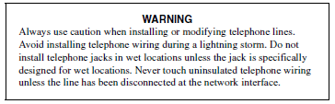
Connecting trunks without PFTU

Procedure 49
Connecting trunks without PFTU

1 From the assignment record, determine the location of the trunk
connection and its associated Terminal Number (TN) at the
cross-connect terminal.

2 With cross-connecting wire, connect the trunk to the TN.

Make sure that the wiring is not reversed and is on the proper
terminals.

The connections for trunks are listed in Table 49 on page 282,
Table 50 on page 283 and Table 51 on page 284.

Connecting trunks with PFTU

Procedure 50
Connecting trunks with PFTU

1 Locate the PFTU terminal blocks at the cross-connect terminal.

2 Cross-connect the first pair of the assigned PFT to the telephone.
Refer to Table 48 on page 280 for PFTU connections.

3 Cross-connect the second pair of the PFT to the TN assigned to
the telephone.

4 Cross-connect the third pair of the PFT to the central office trunk.

5 Cross-connect the third pair of the PFT to the TN assigned to the
trunk.

6 Repeat for each trunk assigned to the PFTU.
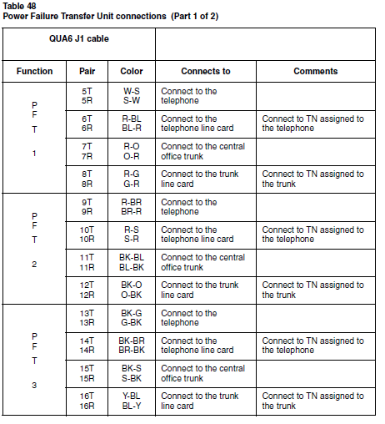
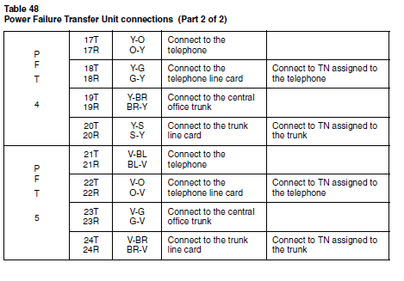
Trunk Connections

NT8D14 Universal trunk card

The universal trunk card provides eight analog trunks which can function in
the modes shown in Table 49 on page 282.
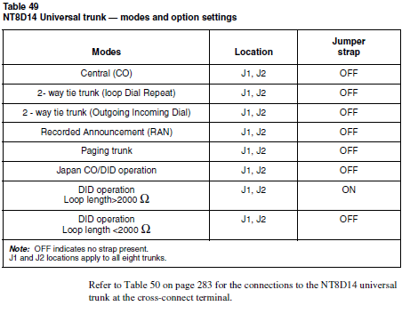
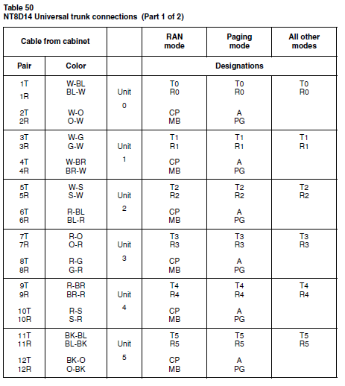
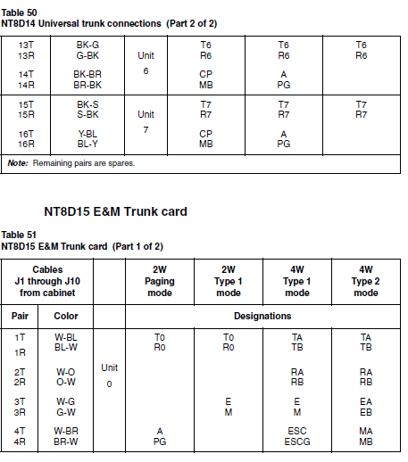
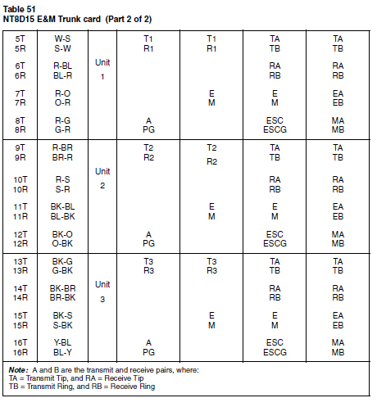
NT6D70 SILC and NT6D71 UILC cards

Refer to Option 11C ISDN BRI Hardware Installation and Maintenance
(553-3011-311) for a complete description of trunk DSL installation and
connections.

Trunk connections (Europe)

E&M TIE trunk card (2-Wire)

Note: Refer to the Intelligent Peripheral Equipment Supplements for a
complete description of European circuit cards.
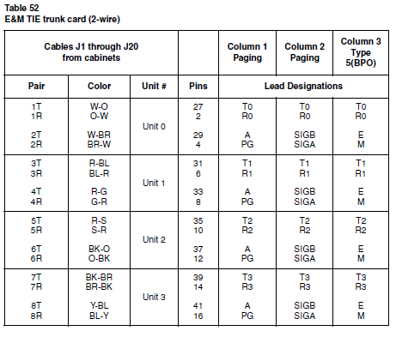
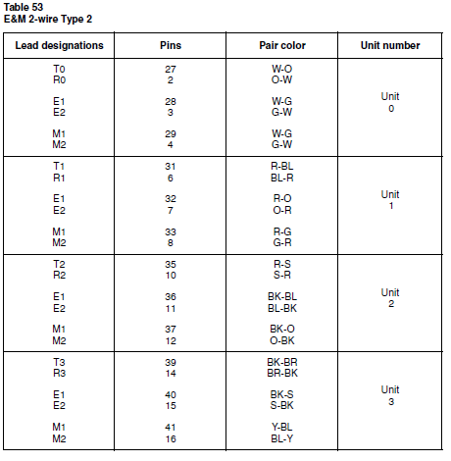

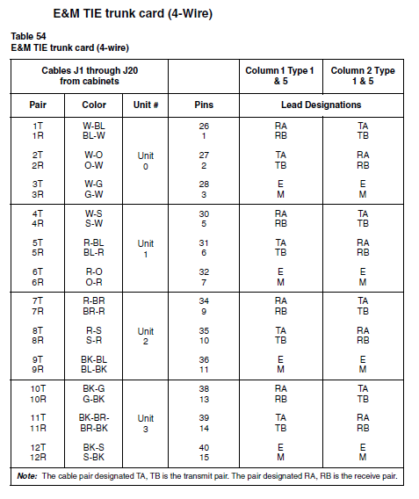
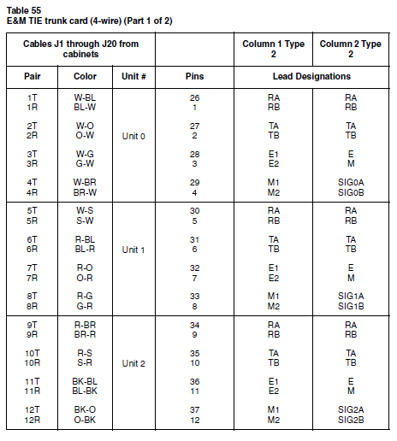
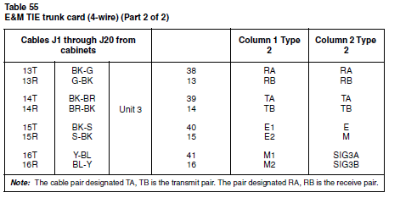
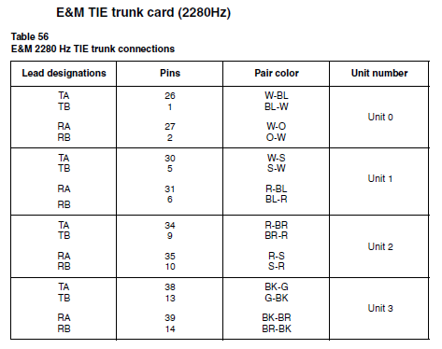
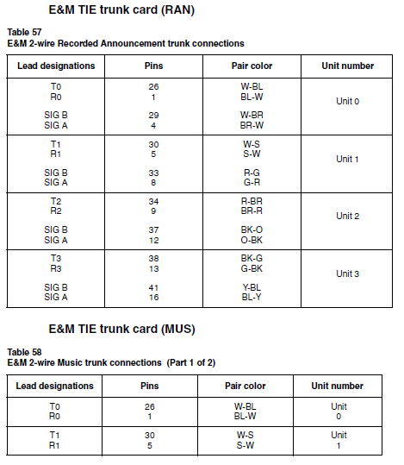
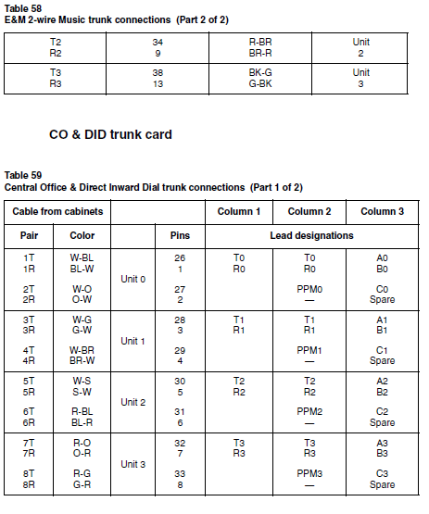
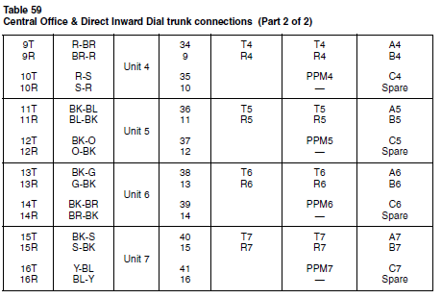
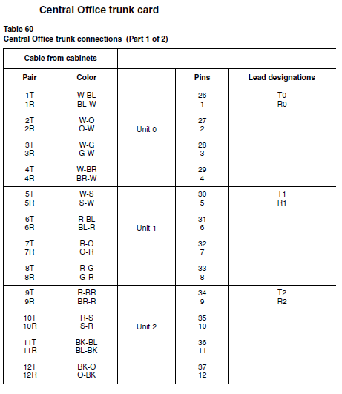
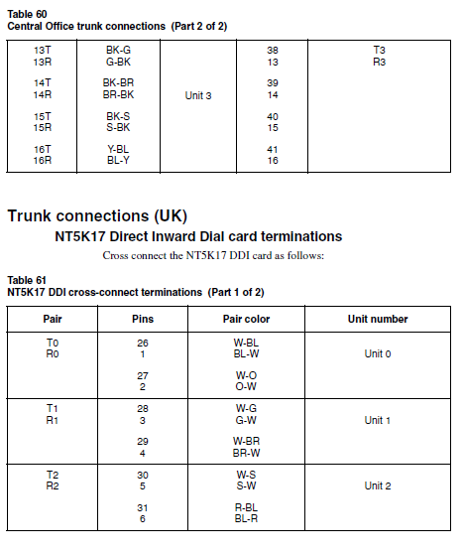
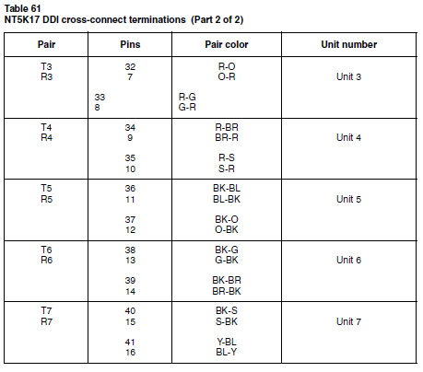
NT5K18 Exchange line trunk card terminations

Cross connect the NT5K18 Exchange line trunk card as shown in Table 62.
Note: The connections on the NT5K18 Exchange line trunk card are
polarity sensitive. Make sure the ground side of the trunk is connected to
the A leg of the NT5K18 circuit. Make sure the -50 volt side of the trunk
is connected to the B leg of the NT5K18 circuit.

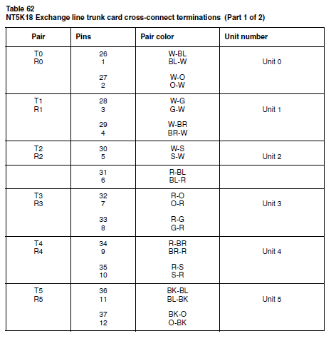
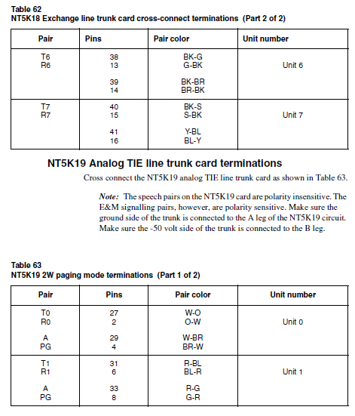
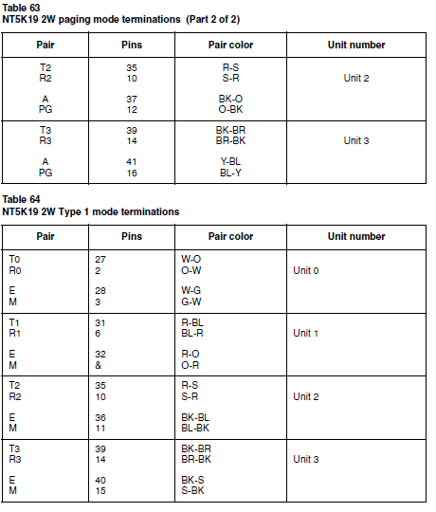
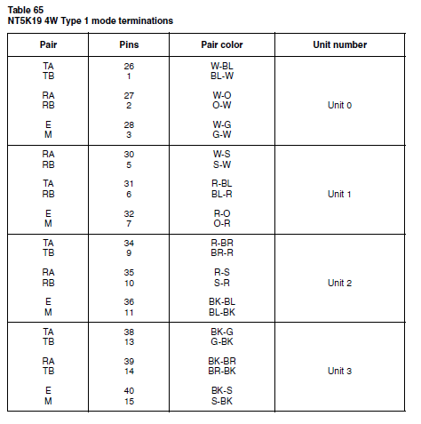
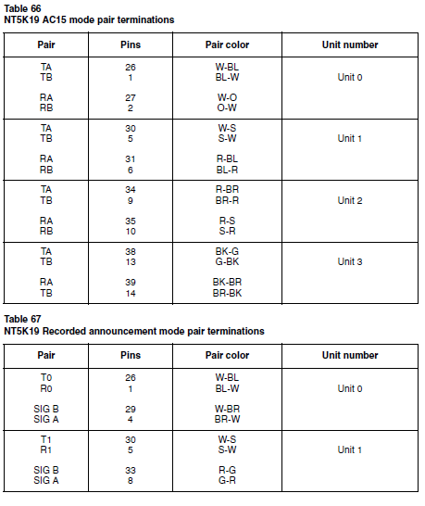
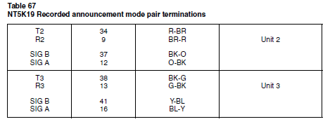
Activating a default model trunk

Due to the automatic thirty second time-out on the administration menu, be
sure that you have prepared the data that you want to input before you begin.
To determine corresponding TNs and trunks, check the location of trunk
cards in the cabinet or use LD 32.

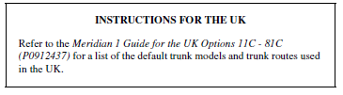

Procedure 51
Activating a default model trunk

1 Pick up the handset of the administration telephone.

2 Enter the Option 11C administration Flexible Feature Code to
access the administration menu.

The prompt “PASSWORD?” appears.

3 Enter the default administration telephone password.

You hear special dial tone, and the prompt
“TASK?”

appears in the top line of the character display.
The second line of the display reads “1 ADD TRUNK”.
4 Select “1 ADD TRUNK” by entering the number “1”.

The prompt “ROUTE ACCESS?” appears on the character display.

5 Enter the access code of the route to which you want to add a
trunk and press the pound key (#).

The prompt
“TN?”
asks you to enter a TN (Terminal Number) from one of the installed
trunk cards.

If you do not enter a valid route number, “TN?” does not appear and
the screen remains the same. If the type of trunk card does not match
the route, the prompt “ROUTE ACCESS?” appears again, and you
hear overflow tone.

6 Enter the TN in Option 11 format (CCUU) and press the pound
key.

The prompt
“MODEL”

appears. If you enter an invalid TN, the display shows “INVALID, TN?”
and you must enter a new TN using the Option 11 format.

7 Press the digits to select a trunk model (as assigned in LD 16).

The character display shows
“OK”.

After a delay of approximately 4 seconds you hear special dial tone.
The sequence is repeated when the prompt

“TN?”
appears on the character display.

The next valid trunk TN is automatically incremented after each trunk
is activated.

8 Terminate the sequence by hanging up the telephone receiver, or

Repeat the sequence by going through the steps again.
By entering “#” when the procedure repeats, you accept the next TN
and are prompted for the model type.

By entering “#” again, you accept the previously accepted model.

Note: The model chosen during the first trunk activation sequence will
be the default model for all subsequent trunks until you hang up the
telephone or manually enter a new trunk model number.

Activating a selected model trunk

Due to the automatic thirty second time-out on the administration menu, be
sure that you have prepared the data that you want to input before you begin.
To determine corresponding TNs and trunks, check the location of trunk
cards in the cabinet or use LD 32.

Procedure 52
Activating a selected model trunk

1 Pick up the handset of the administration telephone.

2 Enter the administration Flexible Feature Code to access the
administration menu.

3 Enter the default administration telephone password.

You hear special dial tone and the prompt “TASK?” appears on the top
line of the character display. The second line of the character display
reads “1 ADD TRUNK”.

4 Select “1 ADD TRUNK” by entering the number “1”.
The prompt

“ROUTE ACCESS?”
appears.

5 Enter the access code of the configured trunk route to which you
want to add the trunk and press the pound key (#).

The prompt
“TN?”

asks you to enter a TN from one of the installed trunk cards. If you do
not enter a valid route number, “TN?” does not appear and the screen
remains the same. If the card does not match the route, the prompt
“ROUTE ACCESS?” appears again, and you hear overflow tone.

6 Enter the TN in Option 11 format (CCUU).

The response
“MODEL?”
prompts you to select a model number for the trunk.

7 Enter a trunk model number for the specified TN and route and
press the pound key.

The character display shows:
“OK”
After a delay of approximately 4 seconds you hear special dial tone
and the sequence is repeated when the following prompt appears on
the character display.
“TN?”

8 Hang up or repeat the sequence.
The sequence ends when the last unit in the card is used and the
program is complete, or when you hang up the telephone receiver.

Note: The model used for the first trunk activated in the sequence will
be the default for all subsequent trunks until the telephone is hung up
unless you manually enter a new trunk model number.

Connecting an external alarm
Contents

This section contains information on the following topics:

General information . . . . . . . . . . . . . . . . . . . . . . . . . . . . . . . . . . . . . . . . 307
Alarm port assigned in software . .. . . . . . . . . . . . . . . . . . . . . . . . . . . . . 307
Alarm through a QUA6 PFTU . . . . . . . . . . . . . . . . . . . . . . . . . . . . . . . . 308

General information

There are two methods of connecting an external alarm to the system:
• through an alarm port assigned in software
• through contacts in a QUA6 Power Fail Transfer Unit (PFTU).

Alarm port assigned in software

The system can be equipped with an alarm port using an analog line
connected to an Analog (2500/500)-type telephone or other similar type of
ringing or alerting device.
The alarm will operate when a BSD090 message indicates a power fault in
the system. Information about BSD090 messages is contained in
Maintenance (553-3001-511).
Procedure 53
Installing an alarm using an alarm port

1 Install an analog (500/2500)-type line as described in “Connecting
the telephones” on page 247.

2 Install an analog (500/2500)-type telephone or other similar
alerting device used as an alarm to the line.

The set can be typically assigned as a Model 20.

3 Use LD 15 and make the following changes. Only the prompts
requiring a response are listed. Press return in response to the
other prompts.

- Enter CHG in response to the prompt REQ
- Enter CDB in response to the prompt TYPE
- Enter the customer number (0-99) in response to the prompt
CUST
• Enter the DN of the line assigned as an alarm port in response
To the prompt ALDN.

Note: If the assigned DN is inadvertently called the alarm will activate.
To avoid false alarms, make sure that the DN is not consistent with the
assigned numbering.

• Press return in response to the remaining prompts.

Alarm through a QUA6 PFTU

A QUA6 PFTU can be used to connect an external alarm through normally
open or normally closed contacts of one of its units. The contacts will operate
under the same conditions as the PFTU itself, and can support the following
capacities:
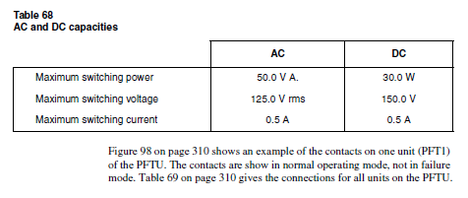

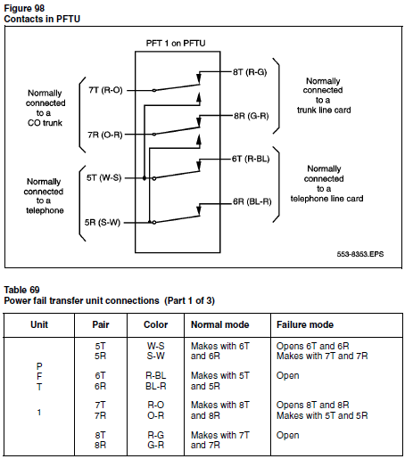
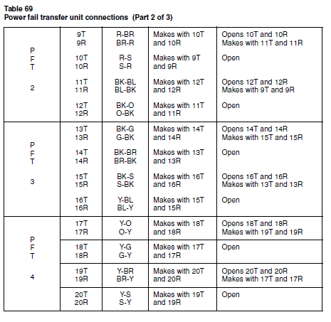
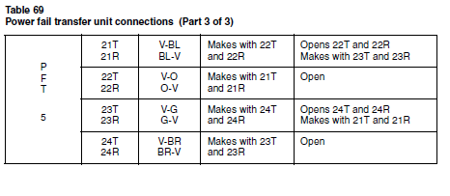

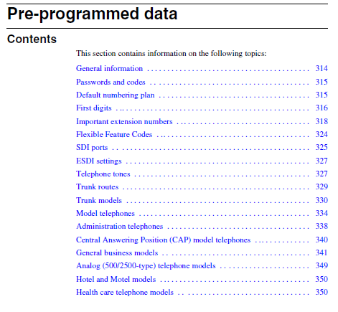

General information

When an Option 11C system is initially installed, customer data must be
entered into the overlay programs. Telephones, for example, must be
assigned features on their keys to allow them to function properly.
However, the Software Daughterboard can be pre-programmed with the
customer data. If you load pre-programmed data into the system during the
Installation process, some overlay entries will be automatically configured onthe telephones.

For example, you can choose a telephone model that has
predetermined feature and key assignments and a preassigned class of
service.

This can be a significant time-saver if you have to program numerous
types of telephone models.

Pre-programmed data is not mandatory for software installation. In fact, the
Software Daughterboard can be programmed with the minimum number of
files to allow the Option 11C to operate.

Passwords and codes

The following table shows each function in the left column and a
corresponding password or code on the right.
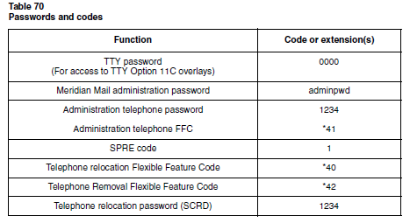
Default numbering plan

The default numbering plan for Option 11C is based on the following
guidelines:

• The default numbering plan uses four digits and starts at 2200.

• The prime extension number (DN) for each telephone is in the range
2200-2XXX.

The value of “XXX” varies depending on the number of
telephones that you have in the system. Any secondary extension
numbers use numbers outside this range.

This arrangement allows
Option 11 and Meridian Mail to automatically configure telephones and
corresponding mailboxes without manual intervention.

• Meridian Mail uses extension 7000 for access, 7001 for Auto Attendant,
7002 for Express Messaging, and 7003 for Prompt Maintenance.
• Meridian Mail Virtual Agents are pre-configured for Card 10 in Unit 0,
1, 2, 8, 9, and 10 of the main cabinet.

• The Central Answering Position has an extension of 7700. This
extension can be changed in LD 15.

First digits

Figure 71 on page 316 shows the default numbering plan for Option 11C:

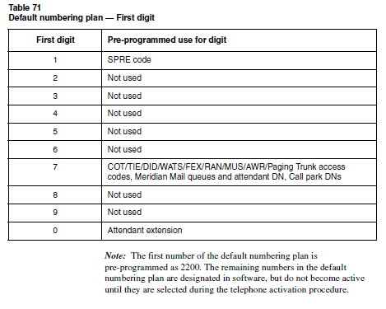
The digit “7” in the default numbering plan is programmed with many system
features to assist you in configuring the Option 11C system. If you have the
Meridian Mail card option software, it automatically configures user mail
boxes to correspond with the 2200 numbering plan. In addition, the
pre-programmed Meridian Mail queues in the Meridian Mail software match
the default data on the Option 11C system

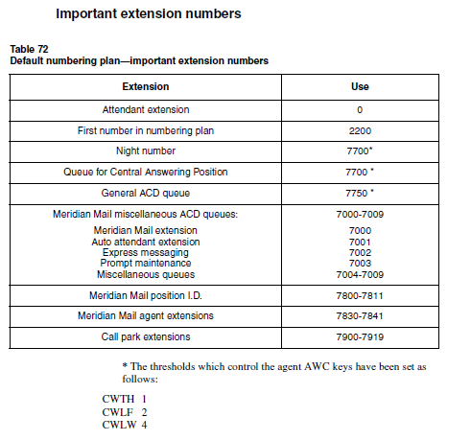
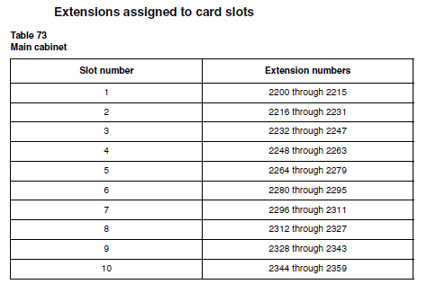
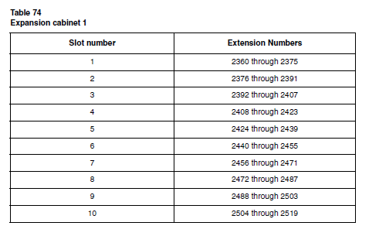
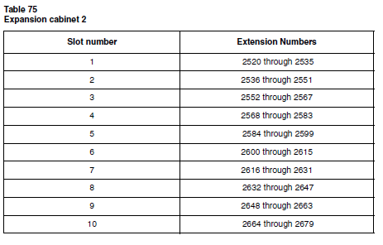
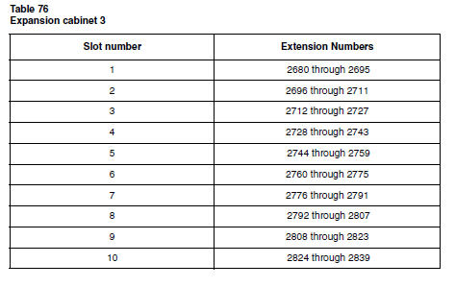
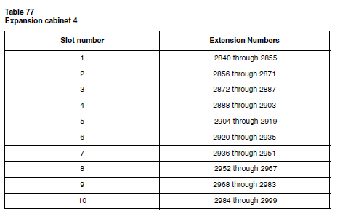

Flexible Feature Codes

Flexible Feature Code (FFC) data is used in many administrative procedures.
The table below lists the FFCs for the Option 11C system.
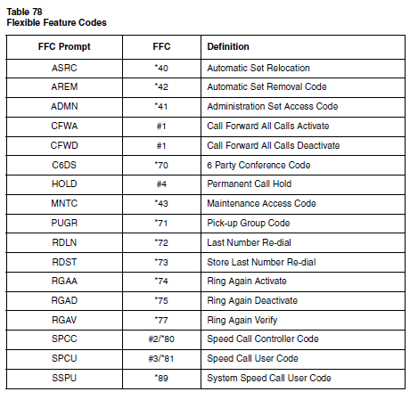

SDI ports

The minimum system port configuration for Option 11C is 3 SDI ports, all of
which can be found on the NTDK20 System Core card.

You can obtain additional ports by installing an NTAK02 SDI/DCH circuit
card. The SDI/DCH card has 4 serial I/O ports with three possible
configurations:

• 2 asynchronous ESDI ports with 2 DCHI ports
- 2 synchronous ESDI ports, or
• 2 SDI ports.

The default SDI port configuration is shown below. The value for “XX” is set
on the faceplate of the CPU/CONF circuit card
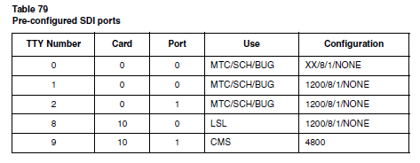
Administration and maintenance terminal port

Option 11E has two pre-configured maintenance ports on the NTBK45
System core card: port 1 and port 2.

Modem port

The pre-configured modem port allows the remote maintenance modem to be
connected with further system programming. This port is pre-configured as
TTY 0 (port 0 on the System core card) and is programmed for Maintenance
(MTC), Service Change (SCH) and BUG messages.
Enhanced Serial Data Interface (ESDI) port

Port 9 is pre-programmed as an ESDI port and supports Meridian Mail. It
functions as a Command Status Link with the settings given in Table 80:
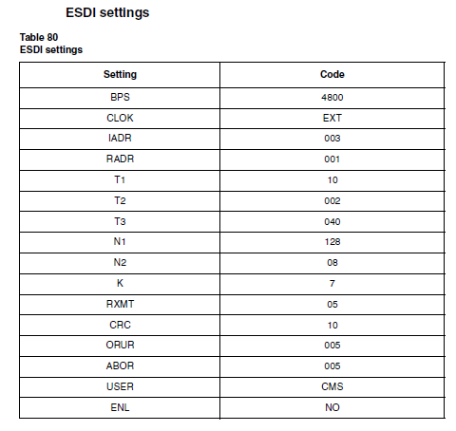

Telephone tones

The telephone tones in North America are as follows:

Dial tone – A continuous tone.

Special dial tone – Three beeps followed by continuous dial tone.

Overflow tone – Like a busy tone, except faster and higher.
Relocation tone – A short high-pitched beep lasting for 4 seconds, followed
by silence.

Trunk routes

Table 81 on page 329 shows pre-programmed trunk route information that
you need on hand to activate and modify trunks.

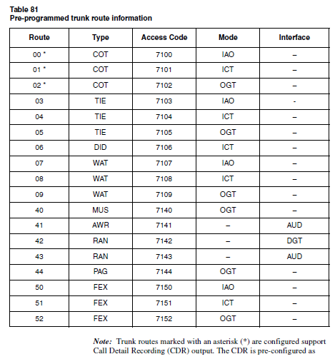

follows:
CDR YES
INC YES
OAL YES
AIA YES

Trunk models

Note: All trunks are programmed as immediate start / supervision = yes,
with the exception of trunks with an asterisk beside them (*). Trunks
marked with an asterisk (*) are set for wink start / supervision = yes.

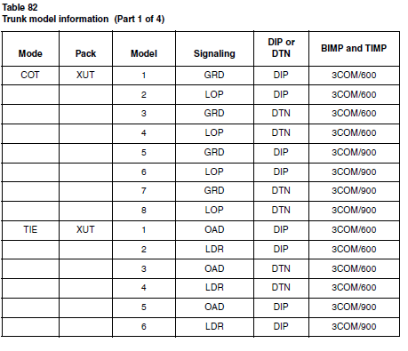

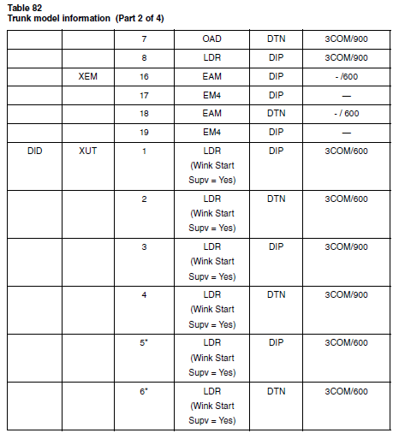
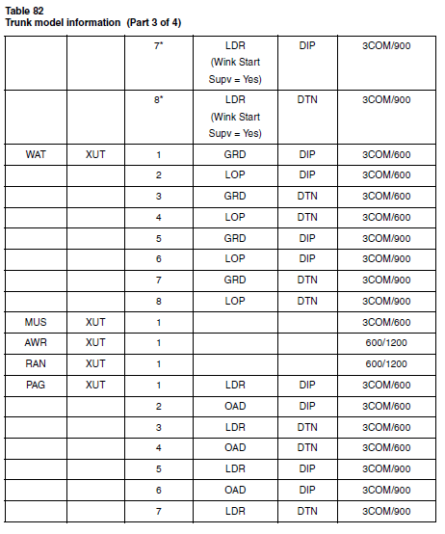

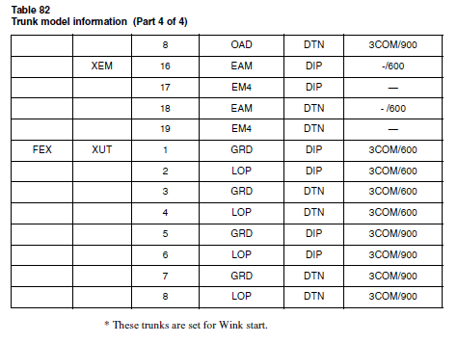

Model telephones

Note: OPS telephones do not have their own telephone models. You
can, however, create OPS models in by entering DD in response to the
CDEN prompt in LD 10.

With the exception of the administration and CAP model telephones, the
models are organized according to software packages, as follows:

Administration telephones
• M2008 - one model
• M2616 - one model

CAP telephones
- M2616 - one model
- M2216 - one model

General Business telephones
• Analog (500/2500 type) telephones - seven models
- M2000 telephones

— M2317 - two models
— M2009 - two models
— M2112 - two models
— M2018 - two models

• M2006 - five models
• M2008 - fifteen models
• M2616 - twelve models
- M2216 - two models
• M3000 - two models.

Hotel and Motel telephones
• 500- and 2500-type telephones - one model

- M2006 - two models
- M2008 - two models
• M2616 - one model

Health Care telephones
- M2006 - one model
• M2008 - four models
• M2616 - two models.

This section provides model numbers for each telephone type and tables
showing the numbering and placement of the keys, and the feature assigned
to each key.

Acronyms for Class of Service options are shown in the following tables for
each model telephone in this section.

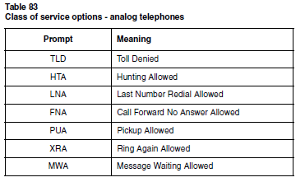
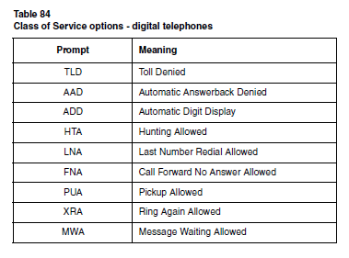

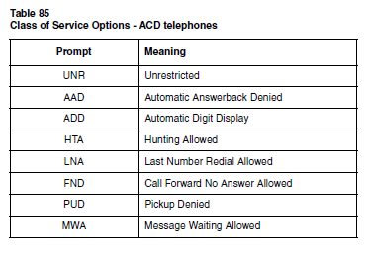
Administration telephones

M2008 model 99

Intended use: Administration (maintenance) telephone
Assigned Class of Service options:
MTA/ADD/LNA/FNA/GPUA/MWA/FBD

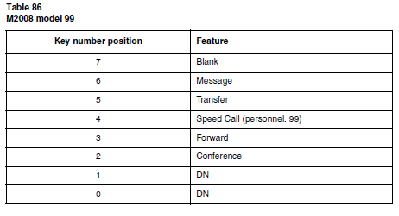
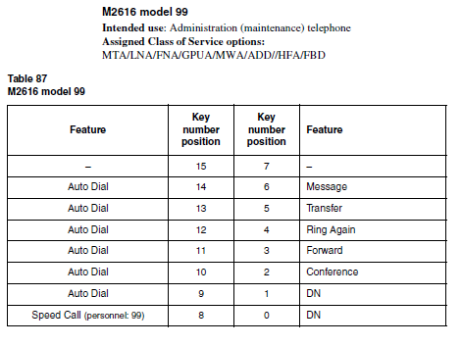

Central Answering Position (CAP) model telephones

M2616 and 2216 CAP telephone model 60

Intended use: Central Answering Position telephone
Assigned Class of Service options:
LNA/FND/GPUA/MWA/ADD/HFD/AGN/FBD/SPV

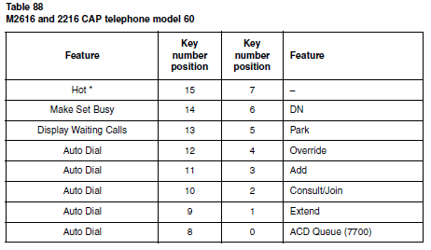
* This key is used as a Hotline to connect to the office paging system. Assign
it with the paging route access code and define it when you activate the
telephone.

Note: With the M2616 CAP you must use an ACD character display. In
the system software, the Extend key is actually called a Transfer key, the
Consult/Join key is called a Conference key, and the Add key is called a
No Hold Conference key.

General business models

M2000 series telephones

The M2000 series telephones - M2112, M2018, M2317, M2009, and
M3000 - are limited to a combined total of 128 model telephones. (In other
words, there can be no more than a combined total of 128 different models for
all the M2000 series telephones.)

It is up to you to make sure that the model associated with the telephone you
are activating is pre-defined. You must select the model associated with the
telephone or the telephone will not work.

M2317 model 20

Intended use: Two-line general business telephone with display
Assigned Class of Service options: FND/GPUA/LND/MWD/ADD/FBD

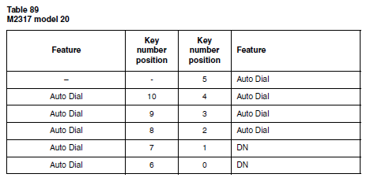
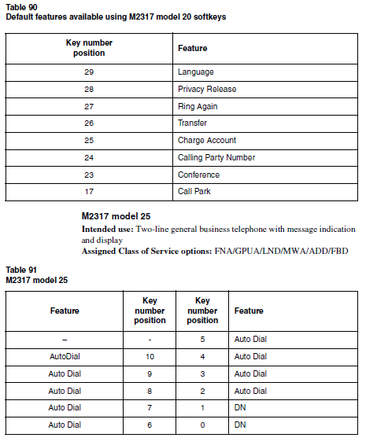

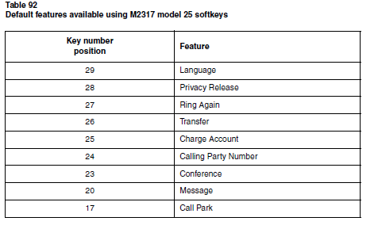

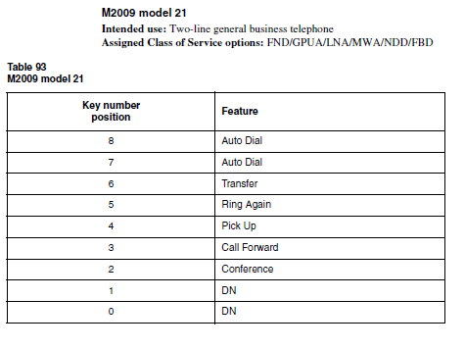

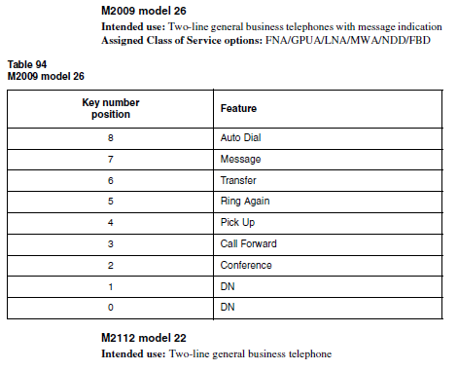

M2112 model 22
Intended use: Two-line general business telephone
Assigned Class of Service options: FND/GPUA/LNA/MWA/NDD/FBD
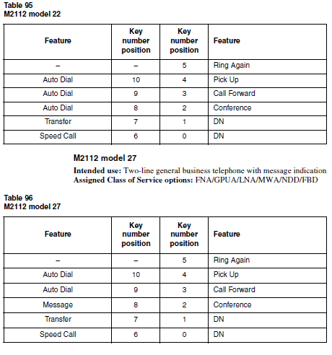
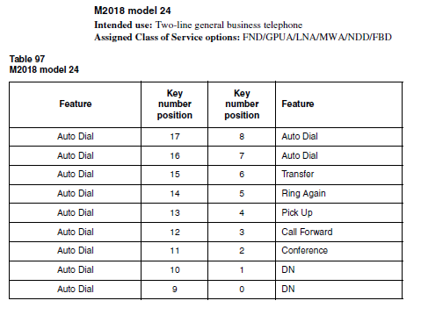
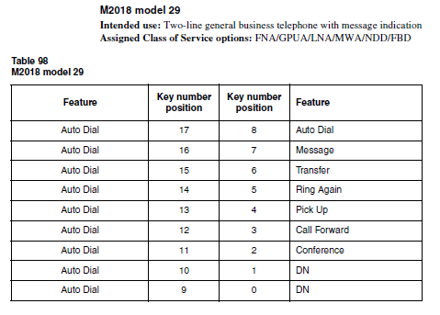
Analog (500/2500-type) telephone models

Note: When you are activating an analog (500-type) telephone, you
must use an analog (2500-type) telephone to define the features. When
you have done this, disconnect the analog (2500-type) telephone and
replace it with the analog (500-type) telephone that you are
activating.Analog (500/2500-type) support personnel telephone models.

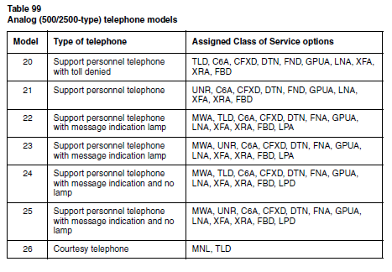
Hotel and Motel models

Analog 500- and 2500-type telephones

Note: When you are activating a 500-type telephone, you must use a
2500-type telephone to define the features. Once you have done this,
unplug the 2500-type telephone and replace it with the 500-type
telephone that you are activating.
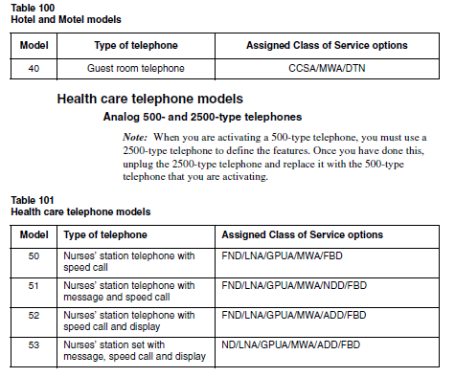

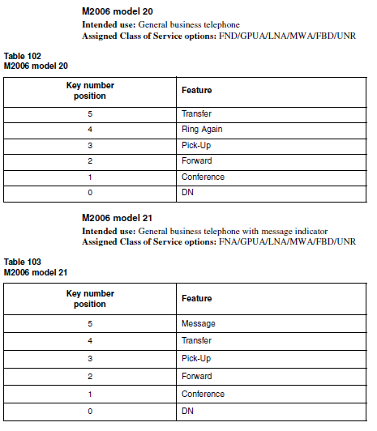
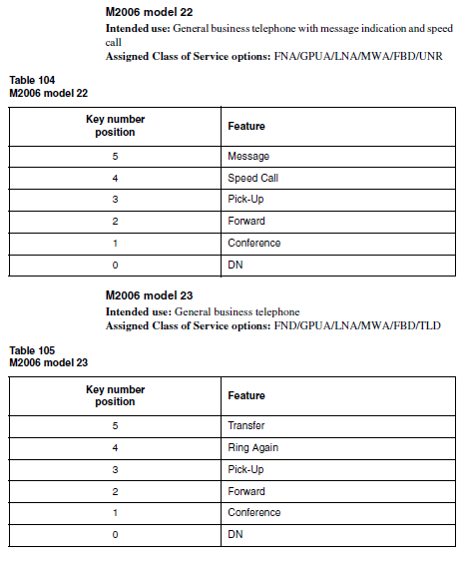
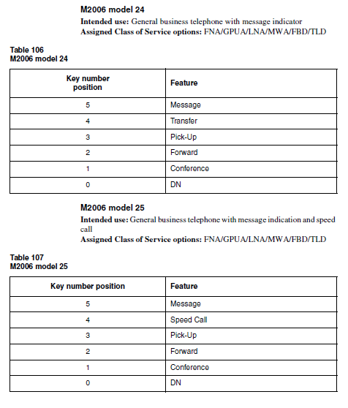
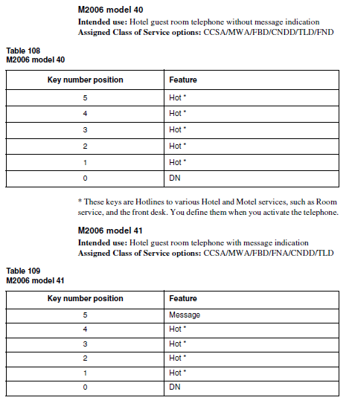
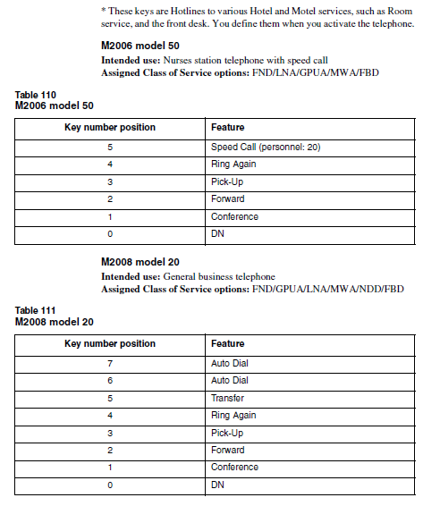
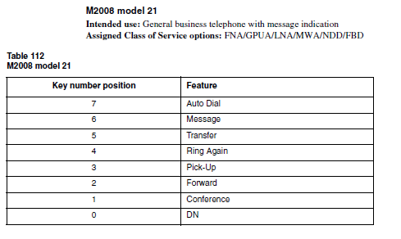

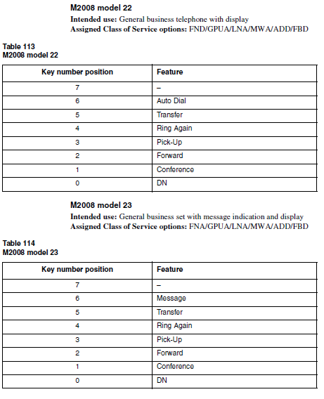
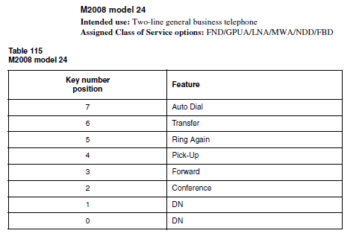
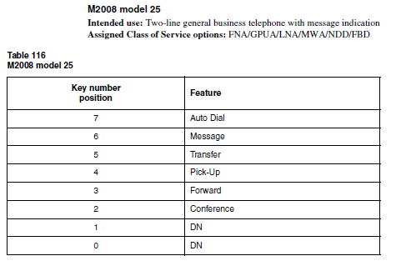
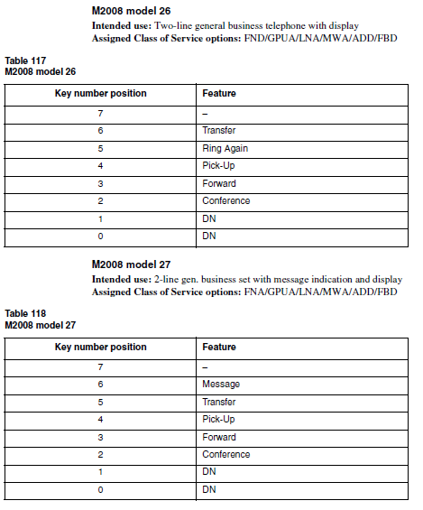
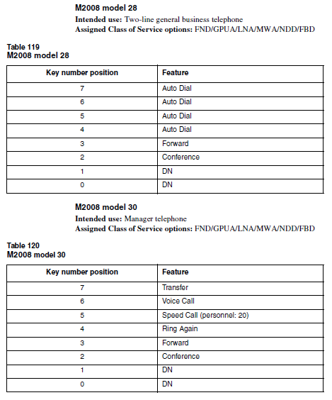
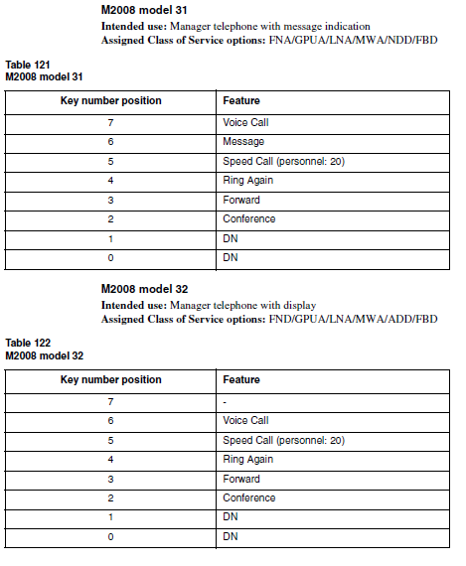
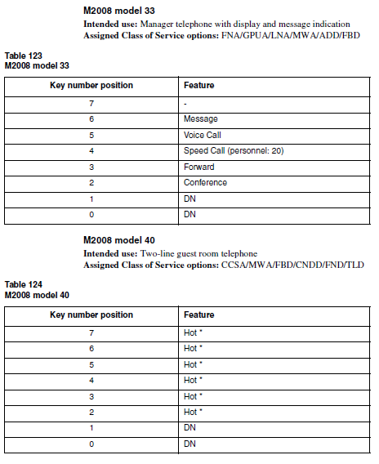
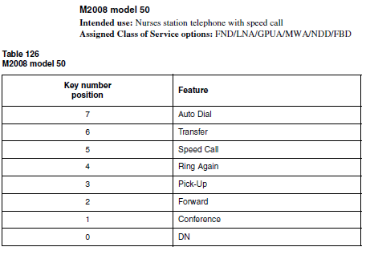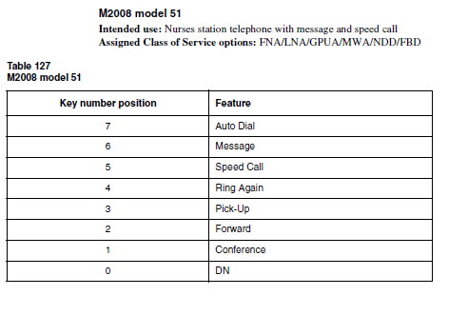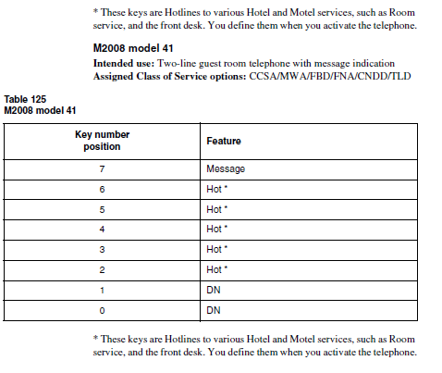
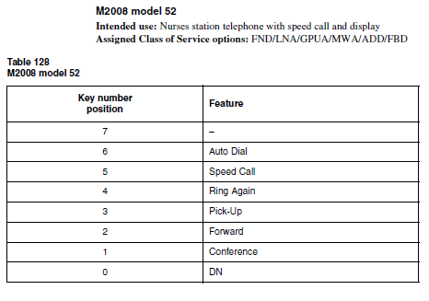
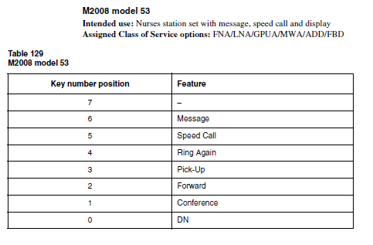

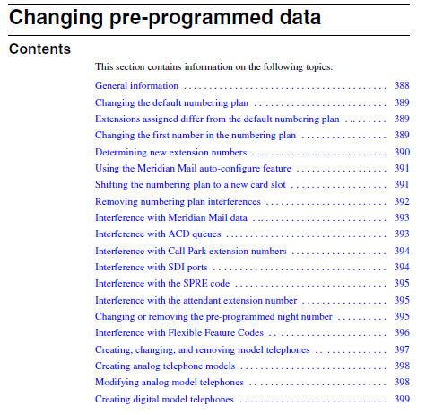

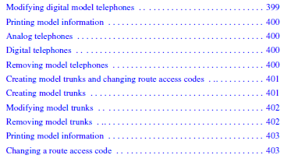
General information

The pre-programmed data on the Option 11C system can provide an effective
starting point for programming the system’s telephone and trunking
information.

This chapter shows how to change the default Option 11C numbering plan.

You may want to change the numbering plan for one or more of the following
reasons:

- to change the first number in the numbering plan
- to shift the start of the numbering plan to another card slot
- the default numbering plan interferes with the system data.

In addition to making changes to the default numbering plan, this section
provides information about modifying model telephone and trunk
programming stored in the Option 11C pre-programmed data
Changing the default numbering plan

For improved performance refer to the Option 11C Survivability Guide
(P0919734) for numbering plan configuration.

Extensions assigned differ from the default numbering plan

Compare the first digits assigned to this system with the default numbering
plan as shown in the “Default numbering plan” .

• If the first digit is in the unused range, change the first number in the
default numbering plan. To do this, follow the instructions in the section
of this chapter called io.

• If the first digit is being used by Meridian Mail, trunk routes, or other
data, you must remove these interferences. Follow the instructions found
later in this chapter in the section called“Removing numbering plan
interferences”

Changing the first number in the numbering plan

To change the first number in the numbering plan perform the following
procedure:

Procedure 54
Changing the first number in the numbering plan

- Pick up the handset of the administration telephone.

- Enter the administration Flexible Feature Code. (For some

countries, this value is listed in the “Flexible Feature Codes” on
page 324.)

3 Enter the administration telephone password. (For some countries,
this value is listed in the, “Passwords and codes” on page 315.)

4 You hear special dial tone and the prompt “TASK?” appears on the top
line of the character display.

5 Press the asterisk (*) three times.
The second line of the character display reads “4 INSTALLATION
OPTIONS'”.

6 Select “4 INSTALLATION OPTIONS” by entering the number “4”.
The character display reads:

1 DEFAULT SETS
2 NUMBERING PLAN

7 Select “2 NUMBERING PLAN” by entering the number “2”.
The character display reads:
FIRST NUMBER (XXXX)?

8 To create a new first number, enter the digits you want and press
the pound key.

9 The number you enter as the first number in the numbering plan is
assigned to slot number one, unit zero of the main cabinet. The default
numbers assigned to the remaining card and unit combinations are
consecutive in the Option 11C system assuming that each slot
consists of up to 16 units.

Determining new extension numbers

If you wish to change the default numbering plan, and need to determine the
extension number that will be assigned to a specific telephone, perform the
following procedure:

Procedure 55
Determine the extension number

1 Identify the line card to which the telephone is connected. Take the
card slot number associated with the card and subtract 1.

2 Multiply this number by 16.

- Add the first extension number in the new numbering plan.

4 Identify the unit number the telephone is terminated on and add it to
the result obtained in step 3.

Example:

Assume the new numbering plan starts at extension number 4500. You wish
to know the extension number of the telephone connected to card 8, unit 12:

- Subtract 1 from the card slot number (8-1):

2 Multiply by 16

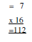
- Add the first extension number: +4500

- Add the unit number: + 12

Number assigned to card 8, unit 12 is 4624

Note: If you are using a three digit numbering plan, follow the same
Procedur
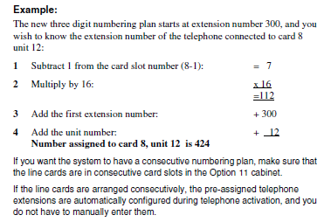
Using the Meridian Mail auto-configure feature

The Meridian Mail auto-configure feature automatically matches up
Meridian Mail mail boxes with telephone extensions. If you have the
Meridian Mail card option and you want to use the Meridian Mail
auto-configure feature, make sure of the following:

• The numbering plan is consecutive
• The first number in the Option 11 system and the Meridian Mail system
are the same.

Shifting the numbering plan to a new card slot

The first number in the numbering plan is assigned to slot 1, unit 0. You may
wish to shift the first number in the numbering plan to a different card slot,
since the TDS/DTR card is pre-programmed for slot 1.
The following procedure describes how to shift the first number in the
numbering plan to a specific card slot.

Procedure 56
Shift the first number in the numbering plan to a different card slot

1 Locate the first line card. Subtract 1 from the card slot number it is
housed in.

2 Multiply this number by 16.

3 Take the first number in the numbering plan and subtract the value
obtained in step 2.

Note: When you enter the value from step 3 in response to the prompt
“FIRST NUMBER (XXXX)?” on the administration telephone menu,
the number is shifted to the appropriate slot.

Example:
The first number in the numbering plan is 2200. If you want the first number
in the numbering plan to be 2300, and the first line card is located in slot 6,
you will carry out the following calculation:

1 Locate the first line card. Subtract 1 from the card slot number it is
housed in.

6 - 1 = 5

2 Multiply the number obtained in step 1 by 16:

X 16 = 80

3 Subtract this number from the first number in the numbering plan:

2300 - 80 = 2220

4 Enter this value in response to the “FIRST NUMBER (2200)?” prompt
on the administration telephone:

FIRST NUMBER (2000)? 2220
Removing numbering plan interferences

This section contains various methods of removing any numbering plan
interferences that may occur.
Interference with Meridian Mail data

The Option 11 system is shipped with pre-programmed data to support a
Meridian Mail card option. The pre-programmed Meridian Mail data may
cause problems in the following situations:

• there is a numbering plan conflict with pre-programmed Meridian Mail
data and the programming required for another feature

• card slot 10 is required for another circuit card.

Obtaining the use of card slot 10

If card slot 10 is required for another circuit card, simply remove the six
Meridian Mail agents programmed for this card slot. To do this, load LD 11
on the TTY and respond to the system prompts as shown below. Repeat the
procedure once for each of the six units that you want to remove.

LD 11
REQ OUT <CR>
TYPE 2008 <CR>
TN 10 XX <CR> “XX” = a value of 0,1,2,8,9, or 10

Obtaining the use of Meridian Mail ACD queues

The Meridian Mail feature also uses a number of ACD queues in the
Option 11 system. Refer to the section of this chapter called “Interference
with ACD queues” on page 393 for information on how to remove this data
from the system.
Interference with ACD queues

The Option 11C has pre-programmed ACD queues for Meridian Mail, the
Central Answering Position, and general purpose ACD. (For some countries,
pre-programmed ACD queues are listed in “Important extension numbers” on
page 318.)
To remove these values, use LD 23.

Note: Before you remove this data from the system, make sure that all
ACD agent information is removed from the queue
In LD 23, respond to the prompts as follows:

LD 23

REQ OUT
TYPE ACD
CUST 0

ACDN XXXX “XXXX” = Value of ACD queue

Repeat for each ACD queue you wish to remove.
Interference with Call Park extension numbers

System call park extension numbers are pre-programmed for the Central
Answering Position. (For some countries, the default call part extensions are
listed in “Important extension numbers” on page 318.)

To remove this data from the system, load LD 50 and respond to the prompts as follows:

LD 50

REQ OUT
TYPE CPK
CUST 0

SPDN XXXX “XXXX” = Value of Call Park extension

Repeat for each Call Park extension you wish to remove.

Interference with SDI ports

Five SDI/ESDI ports are pre-programmed on the Option 11 system. Ports 8
and 9 are associated with the Meridian Mail card option, and ports 0, 1 and 2
are associated with the NTDK20 Small System Controller (SSC) card. Port 0
is associated with SSC card and cannot be removed.

Any of the remaining ports can be removed using LD 17 as follows.

LD 17

REQ CHG
TYPE CFN
ADAN OUT TTY X “X” = the TTY that you are removing.

Interference with the SPRE code

If the pre-programmed SPRE code interferes with the programming required
for the Option 11 system, use LD 15 to remove it. (For some countries, the
default SPRE access code is listed in “First digits” on page 316.) For
customer 0 enter the following in response to the SPRE prompt:

LD 15
SPRE X y “y” = the value of the SPRE code

Note: To define a new SPRE code, type a space and enter the new
number.

Changing or removing the pre-programmed night number

For some countries, the default value of the night number is listed in
“Important extension numbers” on page 318. If you wish to change or remove
the night number, use LD 15.

LD 15

REQ CHG CHG = Change
TYPE CDB CDB = Customer Data Block
CUST x “x” = Customer number
NIT1 bbbb, or X aaaa “bbbb” = the new extension number (DN)

Or

“aaaa” = the current night number
(the night number is now removed).

Interference with the attendant extension number

You cannot remove the attendant extension number entirely from the
Option 11 system data; you can only replace it with another number.

LD 15
REQ CHG CHG = Change
TYPE CDB CDB = Customer Data Block
CUST x “x” = Customer number
.
ATDN xxxx “xxxx” = the new extension number

Interference with Flexible Feature Codes

If the pre-programmed Flexible Feature Codes interfere with the
programming required for the Option 11 system, use LD 57 to remove the
data from the system. (For some countries, default FFCs are listed in
“Flexible Feature Codes” on page 324.)

LD 57
To change one or more access codes, type in the following commands:

REQ CHG, END Change or end
TYPE FFC FFC = Flexible feature codes
CUST 0-31 Customer Number
FFCT YES,(NO) FFC Confirmation tone
CODE aaaa Enter access code prompt (aaaa)
AAAA xx Enter the new access code prompt
(AAAA)
CODE <CR> Return to REQ
REQ END End program

To remove one access code, type in the following commands:

REQ OUT Action request
TYPE FFC FFC = Flexible feature codes
CUST 0-31 Customer Number
FFCT YES,(NO) FFC Confirmation tone
ALL NO Remove specific access code
CODE aaaa Enter access code prompt (aaaa)
AAAA xx Enter the new access code prompt
(AAAA)
CODE <CR> Return to REQ
REQ END End program

To remove all access codes, type in the following commands:

REQ OUT Action request
TYPE FFC FFC = Flexible feature codes
CUST 0-31 Customer Number
FFCT YES,(NO) FFC Confirmation tone
ALL YES Remove all access codes
CODE <CR> Return to REQ
REQ END End program

Creating, changing, and removing model telephones

If you need a model telephone different from the default models provided in
Option 11C software, use overlays to design your own models using the
information in the following table:
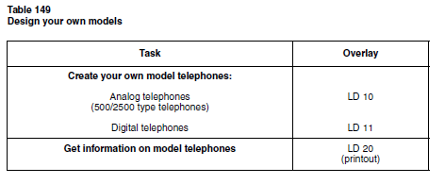
If you require additional assistance when creating your own model telephones
and trunks, refer to the Option 11C Software guides that are shipped with
every system.

Creating analog telephone models

The following information must be entered in LD 10 in order to create an
analogue (500/2500- type) telephone model:

LD 10

REQ NEW
TYPE 500 M
MODL YYY “YYY” = the model number of the telephone that you are
Creating

Enter responses to the remaining prompts in order to complete the new model.
(Refer to the Option 11C Software guides for a complete list of prompts and
possible responses

Modifying analog model telephones

If you want to modify an analog telephone, use LD 10 and type in the
following commands on the TTY:

LD 10

REQ CHG
TYPE 500 M
MODL YYY “YYY” = the model number of the telephone that you are
Modifying

For more information about LD 10 and its associated prompts and
commands, refer to the Option 11 Software Guides that are shipped with the
system.
Creating digital model telephones

When you create model telephones for digital telephones, you must program
key 0 with a function that can act as a prime extension number or its
equivalent. This includes telephones that are programmed to have Single Call
Ringing (SCR), Multiple Call Ringing (MCR), Single Call Non-Ringing
(SCN), Multiple Call Non-Ringing (MCN), and Automatic Call Distribution
(ACD).

For ACD telephones, the model telephone defines the ACD queue. To define
the extension number, you must enter the ID number of the agent or the
Central Answering Position.

The following information must be entered in LD 11 in order to create a
digital telephone model:

LD 11

REQ NEW
TYPE 2XXX M or 3000 M “XXX” = allowed telephone typesMODL YYY “YYY” = the model number of the lephone that you are creating (between 1 - 127)

Enter the responses to the remaining prompts in order to complete the new
model. (Refer to the Option 11C Software guides for a complete list of
prompts and possible responses).

Modifying digital model telephones

If you want to modify a digital telephone, load LD 11 and type in the
following commands on the TTY:

LD 11

REQ CHG
TYPE 2XXX M or 3000 M “XXX” = allowed telephone types
MODL YYY “YYY” = the model number of the telephone that you are
Modifying
For more information about LD 11 and its associated prompts and
commands, refer to the Option 11C Software guides that are shipped with the
system

Printing model information

To print information about model telephones, use LD 20.

Analog telephones

LD 20

REQ PRT
TYPE 500 M
MODL YYY “YYY” = the telephone model number.
If you want to print all of the models for
this telephone type, leave this value blank.

Digital telephones

Note: To print M3000 telephone models, you must enter “TYPE 3000
M”. If you enter “TYPE 2XXX M”, you print all the Meridian Digital
Telephone models except the M3000.

LD 20
REQ PRT
TYPE 2XXX M or 3000 M “XXX” = the telephone type
MODL YYY “YYY” = the telephone model number
(between 1 - 127) If you want to print all
of the models for this telephone type, leave
this value blank.

Removing model telephones

Use LD 10 to remove analog telephone models and LD 11 to remove digital
telephone models. Respond as follows to the prompts in either overlay:

LD 10 or LD 11

REQ OUT
TYPE XXXX M “XXXX” = telephone type for the model
you are removing (Example: 500, 2006,
2317, 2216, 3000, etc.)
CUST 0
MODL YYY “YYY” = the model number associated
with the telephone type you are removing
(Valid range is 1-127).

Creating model trunks and changing route access codes

If you need a trunk that is different from the default models provided in
Option 11 software, use overlay 14 to design your own models. Route access
codes are changed using the administration telephone.

If you require additional assistance when creating your own model telephones
and trunks, refer to the Option 11 Software guides that are shipped with every
system.

Creating model trunks

To create a new model trunk, load LD 14 and type in the following commands
on the TTY:

LD 14
REQ NEW
TYPE aaa M “aaa” = the type of trunk that you are
creating (TIE, COT, WATS, and so on).

MODL YYY “YYY” = the model number of the trunk that you are creating
(between 1 - 127)

XTRK XUT, XEM, XCOT, This prompt only appears when you
XDID define the first model in a group. Each
group consists of 16 consecutive model
definitions. (Refer to the group boundaries
listed below.) Once the first model in a
group is defined, the remaining model
numbers in the group(s) are assumed to
be of the same type.

Group boundaries are as follows:

1-15, 16-31, 32-47, 48-63, 64-79. 80-95, 96-111, 112-127.

Examples:

If, for example, you define a model trunk as XUT, with a model number of
12, all models in the group 1-15 will automatically be XUT models. If you
define another model trunk as an XEM, with a model number of 33, all
models in the group 32-47 will automatically be XEM models.

Note: When you create trunk models you are not prompted for the trunk
route or member number. This information is defined by using the
administration telephone to program the XUT or XEM circuit card.
For more information about LD 14 and its associated prompts and
commands, refer to the Option 11 Software guides that are shipped with the
system.

Modifying model trunks

If you want to modify a trunk, load LD 14 and type in the following
commands on the TTY:

LD 14

REQ CHG
TYPE aaa M “aaa” = the type of trunk that you are
Modifying

MODL YYY “YYY” = the model number of the trunk
that you are modifying (between 1 - 127)

Removing model trunks

To remove a trunk model from the system, load LD 14 and respond to the
prompts as follows:

LD 14

REQ OUT
TYPE XXX M “XXX” = the trunk type of the model that
you are removing (Examples: COT, TIE,
DID, FEX, WAT, etc.)
CUST 0
MODL YYY “YYY” = the model number associated
with the trunk type you are removing
(Valid range is 1-127).

Printing model information

To print information about model trunks, load LD 20 and type in the
following commands on the TTY:

LD 20

REQ PRT
TYPE TTTT M “TTTT” = the trunk type
MODL YYY “YYY” = the model number. If you want to print all of the
models for this trunk type, leave this value blank.

Changing a route access code

Use this procedure to change a route access code.

Procedure 57
Changing a route access code

- Pick up the handset of the administration telephone.

2 Enter the administration Flexible Feature Code to access the
administration menu. (For some countries, this value is listed in
“Flexible Feature Codes” on page 324.)

3 Enter the default administration telephone password. (For some
countries, this value is listed in “Passwords and codes” on
page 315.)
You hear special dial tone and the prompt
“TASK?”
appears on the top line of the character display. If you press the
asterisk, “2 CHANGE ROUTE ACCESS” appears on the second line
of the character display.

4 Select “2 CHANGE ROUTE ACCESS” by entering the
number “2”.

The prompt
“ROUTE ACCESS?”
appears on the character display.

5 Enter the access code of the route to be modified and press the
pound key (#).

The prompt

“NEW ACCESS CODE?”
asks you for a new access code for the route.

6 Enter the new access code and press the pound key.
The display shows

“CODE CHANGED”.
After a delay of approximately 4 seconds you hear special dial tone
and the sequence is repeated when the prompt

“ROUTE ACCESS?”

appears.
OR

If the route access code is not available for use, you hear overflow
tone.

The display shows
“USED, ROUTE ACCESS?”
and you must repeat this step.

You must enter a different access code. This sequence continues
until you enter an appropriate new access code.

7 Terminate the sequence by hanging up the telephone, or
Repeat the sequence by going through the steps again.

Cambiar El nombre a una extensión:
LD 95
CND000
MEM AVAIL: (U/P): 472449 USED: 117374 TOT: 589823
DISK RECS AVAIL: 426
REQ chg------------------cambio
TYPE name---------------nombre
CUST 0-------------------cust, por lo regular siempre es 0
CPND_LANG--------------enter
DIG ----------------------enter
DN 2696-----------------numero de la extension a la que le vas a cambiar el nombre
NAME SITE---------------nombre que le vas a poner a la extension
DISPLAY_FMT------------enter
DN -----------------------enter
DCNO---------------------enter
MEM AVAIL: (U/P): 472449 USED: 117374 TOT: 589823
DISK RECS AVAIL: 426
REQ
Es una impresión que saque de un cliente, este es el procedimiento para cambiar un nombre de extensión, si vas a dar de alta un nombre nuevo, le tienes que poner en la parte del REQ new y lo demás es lo mismo.

